Password Protecting and Locking your Computer

It is highly recommended in today’s working environment that everyone is more vigilant in protecting their personal privacy and those whose information we collect.

Here at the Survey Research Operations, it is important that you practice locking your workstation when you are not in your cubicle or office and ensure that you are password protected.

What is the best password?

The best password is one that is 8-12 characters long and includes the following:

- At least one CAPITAL letter
- At least one lowercase letter
- At least one number
- At least on special character, e.g., ! @ # $ %
Strongly advised password tips:

- Do NOT use any common words/phrases or items in your environment.
For example, the word “calendar” is not suggested since most have one at their desk and anyone wanting to crack your password just needs to look around at your desk or walls.
- Do NOT use any personal information, such as, maiden name, street address, children’s names or anything someone can do a quick search to find more about you.
- Do NOT write your password down. Memorize your password right away and lock it away in your head.
- NEVER give your password to anyone including any IT professionals. They have other ways of accessing your desktop or laptop if need be.
- If you do use words/phrases that can be found in the dictionary, replace letters with numbers or special characters.
For example, Pr3ttyWom@n or S1mon$ays

Locking your computer

By locking your computer when you step away, you ensure that a password is needed to access it. It is very important that you always lock your computer even if you think you are stepping away for a few seconds. All it takes is for you to get sidetracked in a conversation and your computer is open to anyone who can now access the information stored on your hard drive or the network drives.

Windows XP

If you are still on a Windows XP machine there are two different ways to lock your computer.

- The quickest way to lock our computer is by pushing the Windows and L keys at the same time. This is a shortcut built into the OS to lock the computer.
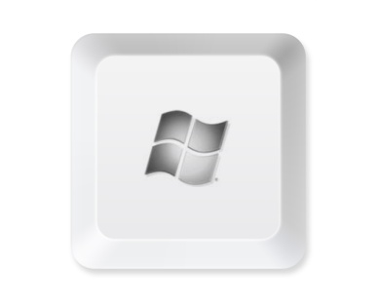⁺
- The other method to lock your computer is to press Ctrl + Alt + Delete keys.
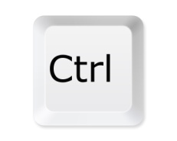 ⁺ 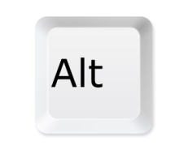⁺ 
Then click the “Lock Computer” button.
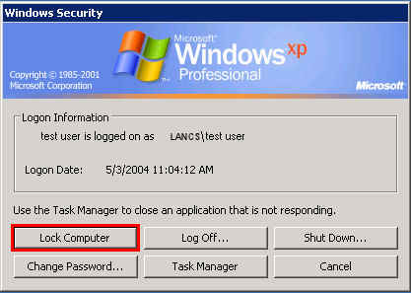

Windows 7

If you are on a Windows 7 machine there are three different ways to lock your computer.

- The quickest way to lock our computer is by pushing the Windows and L keys at the same time. This is a shortcut built into the OS to lock the computer.
⁺
- Another method to lock your computer is to press Ctrl + Alt + Delete keys.
⁺ ⁺
Click “Lock this computer”

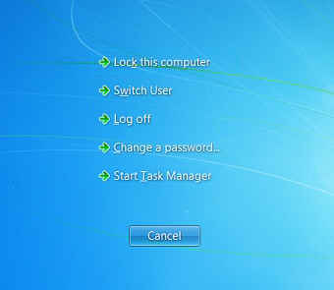

- The last method is done by clicking the Start button or pressing the Windows key


Click the right-facing arrow in the bottom right of the Start menu and click “Lock”.
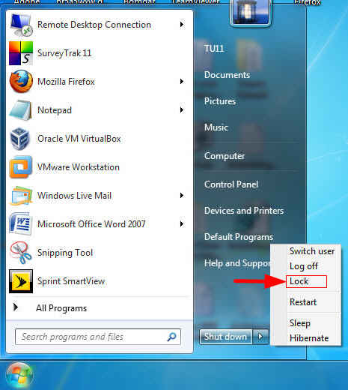

Screen Saver

It happens to everyone, but you get pulled away for an urgent matter and forget to lock your computer. You can tell the Windows screen saver program to “lock” your computer upon activating your screen saver. This is your last resort, and should not be relied on to better secure your computer.

Windows XP

- Right-click anywhere on your desktop.

- Click Properties.
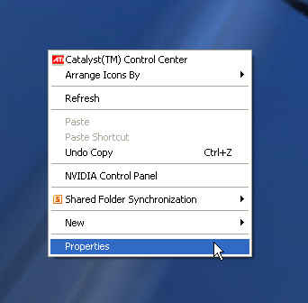
- Click the “Screen Saver” tab.
- Select a screen saver on the drop down, change the wait time to 10 minutes and check “On resume, password protect”.
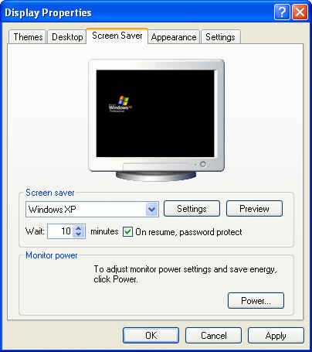

Windows 7

- Right-click anywhere on your desktop.
- Click Personalize.
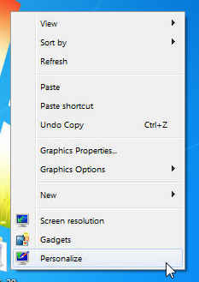
- Click the “Screen Saver” link in the bottom right-hand corner.
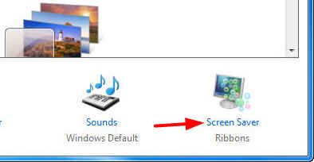

- Select a screen saver on the drop down, change the wait time to 10 minutes and check “On resume, password protect”.
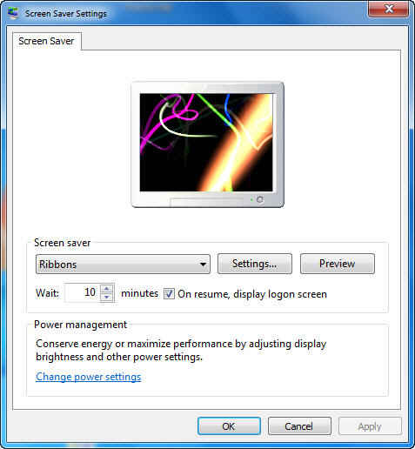

The higher you set this, the more likely anyone can access your computer before the screen saver comes on.
The higher you set this, the more likely anyone can access your computer before the screen saver comes on.

