Tenrox User Manual
Table of Contents

Section 1 -- The Timesheet 1
Getting into Tenrox 1
Timesheet display 2
Entering Time 6
Time Entry checklist 10
Deleting and Correcting Time Entries 10
Entering Notes on a Timesheet 11
Adding Your Own Timesheet Notes 13
Running Totals 14
Submitting Your Time 16
Timesheet Rejection 17
Timesheet Notes 17
Editing and Correcting Submitted Timesheets 18
Editing and Correcting Multiple Projects 19
DCS Rejection 19
Copying and Pasting Time Entries 21
Copying Entire Timesheets 22
Entering Overnight Travel 24
Entering a Shift Differential 26
Timesheet submission summary 27
Section 2 -- Expense Reports 28
Expense Report display 28
Creating a New Expense Report 29
Adding a New Expense Entry 32
Mileage Expenses 39
Changing Mileage Entries 41
Gross and Total Cost Amounts for Internet Partial Expenses 41
Entering/Editing Memo Entries Directly From an Expense Entry Line 42
Copy Button 42
Adding Notes to Expense Reports 43
Copying and Pasting Notes and Memos 45
Per Diem information 45
Deleting an Expense Entry 46
Expense Entry checklist 47
Submitting the Expense Report 48
R Payment Paperless Expenses 49
Expense Report Rejection 49
Editing an Existing Expense Report 51
Sorting Your Expense Reports 51
Paging Through Your Expense Reports 52
Deleting an Expense Report 54
Other Expense Section Features 55
Returning To the Timesheet View, and the Charges Tab 55
Travel Advances 56
Reimbursement Processing 59
Exiting Tenrox 59
Section 3 -- Interviewer Payroll and Expense Guidelines 62
Tenrox 62
Reporting Time 62
Faxing 63
Reporting Expenses 63
Receipt Reminder 64
A Note on SRO Policy for safe rentals for travelers: 64
Accounting Rejection 65
Pay Rates and Raises 65
Payroll Deductions 65
Direct Deposit 65
Overtime 65
Credit Hours 66
Working on Holidays 66
Overnight Travel Policy 66
Overnight Travel Differentials 66
Travel Advances 67
Per Diem Information 68
Recording Per Diem Information 68
Full versus Partial Per Diem 69
Breakfast Per Diems and the First Day of Travel 70
Shared Travel 70

Appendices
Appendix 1 – Field Interviewer Pay Schedule 2006
Appendix 2 – Tenrox Definitions, Instructions, Help, Tenrox Work Types
Appendix 3 – Expense Categories
Appendix 4 – Sample Forms: Timesheet, Expense Submission, Travel Advance
Appendix 5 – Workflow Sheets: Timesheet, Expense Report, Travel Advance
Appendix 6 – Instructions and Sample Forms for Submitting Tenrox Data via Email: Timesheet, Expense Report, Travel Advance

Section 1 -- The Timesheet

If you have questions about Tenrox, or encounter any unexpected events when using it, contact your Team Leader or Production Manager. If this does not resolve the issue, contact us by email by typing in “DCS Tenrox Processing Group” in the To field of your email (or you can type in the actual email address: dcstenroxprocessinggroup@isr.umich.edu).

Please also feel free to call us at 1-800-321-7104, option 2.

Getting into Tenrox

- Connect to the internet.
- Once you have connected to the internet, double-click on the Tenrox icon on your desktop. This will take you directly to the Tenrox Logon Screen:

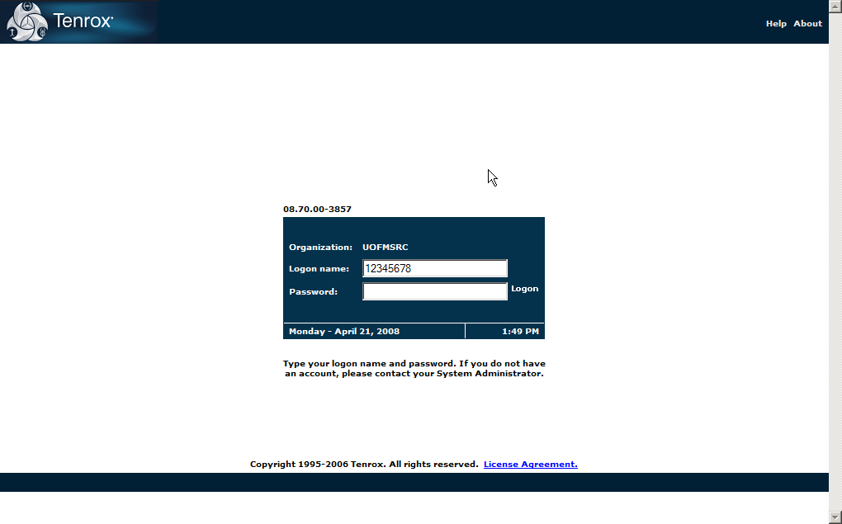
Fig. 1.1. Tenrox logon screen.

- On the Logon screen you will be asked to enter your logon name and your password. Type in your logon name (your 8-digit UM ID--it may already be filled in) and password, then left-click on the word “logon.”

Note: in Tenrox, you don’t need to double-click: only a single left-click is needed.

You have now entered Tenrox!

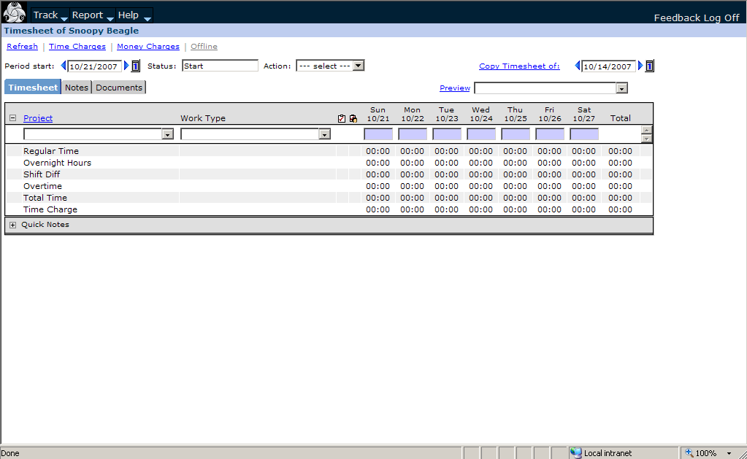

Fig. 1.2. Tenrox timesheet entry screen

Note: As a security precaution, if you enter your login or password incorrectly three times in a row, Tenrox automatically suspends your access. If Tenrox tells you that you are suspended, please contact the DCS Tenrox Processing Group for assistance.

Timesheet display
The first screen displayed will be the current week’s timesheet. At the upper left-hand corner of the Tenrox screen are the tabs:

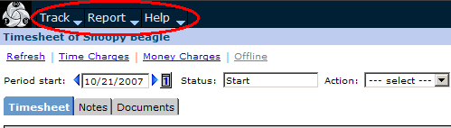
Figure 1.3. Tabs

You’ll use the Track tab to change the view (this will be explained in the relevant sections below). Please do not use the Report and Help tabs. For assistance, please refer to this manual, your supervisor, or contact the DCS Tenrox Support Group.

At the far right-hand corner, you’ll see the Log Off link:

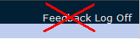
1.4. Log Off link

Click on the Log Off link to exit Tenrox. (See instructions at the end of this manual.)

Please do not use the Feedback link. Any questions should be directed to either your supervisor or to the DCS Tenrox Support Group.

The Refresh, Time Charges, and Money Charges links appear below the tabs:

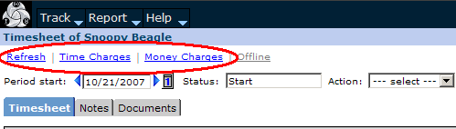
Fig. 1.5. Blue Links.

- The Refresh link is used to update the timesheet display after making changes.
- The Time Charges link is not used.
- The Money Charges link allows you to view any bonus payments or other adjustments that have been added to your timesheet.

On the next line, you will see the Period start box:

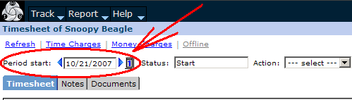
Fig. 1.6. Period start box.

The Period Start displays the first date (Sunday) of that week’s timesheet. The blue arrows allow you to move forward or back in one week intervals.

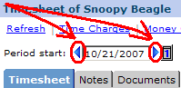
Fig. 1.7. Period start.

The calendar option, denoted by the little grey box with the number “1” inside it, allows you to use a calendar to move to any date. Simply left-click on the grey box to open the calendar feature.

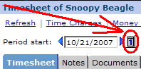
Fig. 1.8. Calendar option.

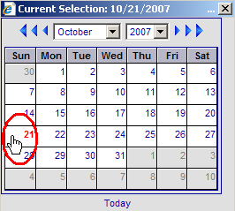
Fig. 1.9. Calendar feature.

Click on a date (or click on “Today” for that day’s date) to select a date. The screen will refresh and display the timesheet for the week of the date you selected.

You can also use the control buttons at the top of the calendar to change the month and year displayed. In the center are drop-down menus for selecting month and year.

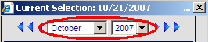
Fig. 1.10. Calendar drop-down menus

You can use the smallest arrows to the left and right to advance the calendar backwards and forwards one month.

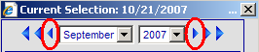
Fig. 1.11. Fall back/advance one month

You can use the middle arrows to the left and right advance the calendar backwards and forwards one year.

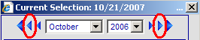
Fig. 1.12. Fall back/advance one year

(The largest arrows shift the date by five years; you won’t be using these.)

Moving further across that line on your timesheet, you will see the Status box.

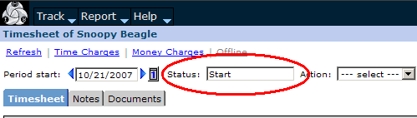
Fig. 1.13. Status box.

The Status box displays the current status or state of a timesheet. See the Timesheet Workflow (Appendix 5) for a detailed overview of the approval process.

Next you will see the Action box:

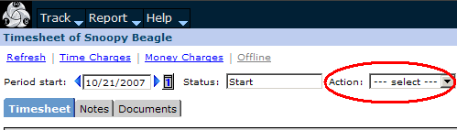
Fig. 1.14. Action box.

This allows you to move your timesheet to another status. It will be discussed in detail later in the manual.

Moving down to the next line, you will see three tabs on your timesheet, labeled “Timesheet,” “Notes,” and “Documents”:

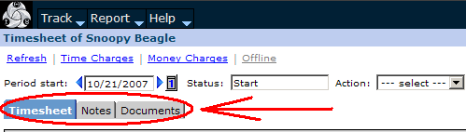
Fig. 1.15. Timesheet tabs.

- The Timesheet tab displays your timesheet. When you log onto your timesheet, it will normally default to this tab.
- The Notes tab displays all the notes on a timesheet. We will return to notes later on.
- The Documents tab is not currently being used.

Entering Time
To enter time worked on a timesheet:

- Select a project.

- Left-click on the long box below the word “Project,” or on the black triangle to the right of this bar. This will open a drop-down list.
- Left-click on the name of the project you wish to enter time for, from the drop-down list.

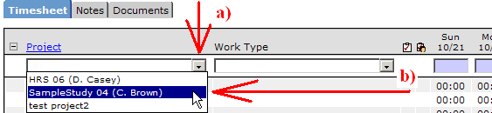
Fig. 1.16. Project drop-down list.

(Note: The timesheet only accepts time worked. You must use the Expense view to record expenses. This is discussed in detail in Section 2 of this manual.)

- Select the work type associated with the activity for which you are billing hours.

- Left-click on the long box below the words “Work Type,” or the black triangle to the right of the words Work Type, to open the drop-down list.
- Left-click on the name of the appropriate Work Type for your time entry, from the drop-down list.
- Note that you can use the scroll bar to move up and down the list of work types.

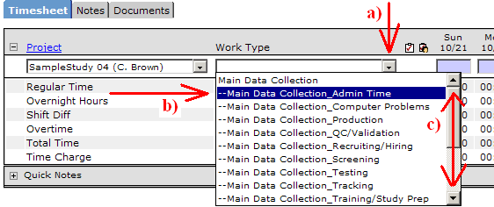
Fig. 1.17. Work Type list.

A work type has two components: a task (for example, Main Data Collection) and an activity (for example, Travel). Main Data Collection all by itself is not a work type; it is called a placeholder. Main Data Collection_Travel, however, is a work type. The timesheet will not accept entries for placeholders. You must select a work type from the work type drop-down menu. A complete list of work types is available in Appendix 2 of this manual. The work types that are available will change relative to the phase of the project. Questions about work types should be directed to your Team Leader or Production Manger.

Sometimes a project or work type name is too long to fit in the Project or Work Type field. You can always move the mouse cursor over the field and wait a few seconds for the tooltip to pop up—it will display the full text of the field.

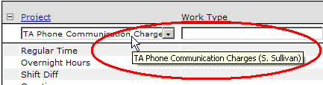
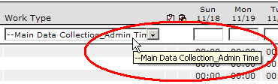
Fig. 1.18. Using the tooltips to view the full field name.

- The next step is to left-click on the appropriate box for the task and date. Note that the cursor changes to an I-bar symbol when it is moved over an empty box.

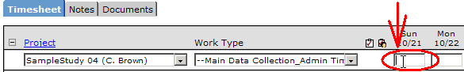
Fig. 1.19. Time entry date box.

- Enter the time you worked on the task. Time is entered by hours, followed by a colon, then minutes, in five-minute increments.

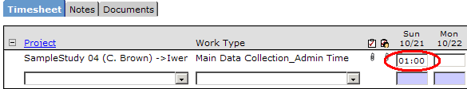
Fig. 1.20. Time entry.

If you worked less than an hour, type in a colon, and enter the minutes. Use a colon when entering hours and minutes, and use 5-minute time increments when entering time.

- Once you have entered your time, to complete the entry, left-click anywhere else on the screen. This will complete the time entry. Once a time entry has been completed a new blank line will appear on your timesheet.

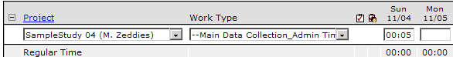
Fig. 1.21. An incomplete time entry—you need to click somewhere to complete it.

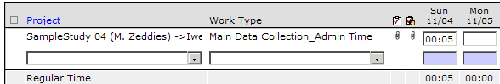
Fig. 1.22. A complete time entry—Project and Work Type are saved, menus move down,
time is added to the Regular Time totals.

To enter time for another work type, repeat the steps above. If you are entering time for the same project and work type, you do not need to reselect the work type. Just move your cursor to the box for the date that this activity was performed, on that same line, and make your time entry. Once time has been entered the timesheet should resemble the example below. (Projects are listed alphabetically.)
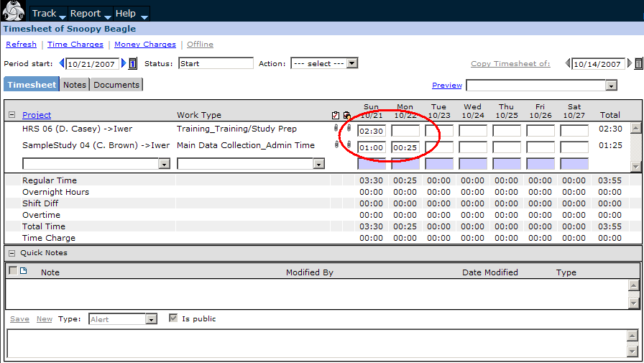Fig. 1.23. Timesheet with time entered.

Time Entry checklist

- Select a project (if it isn’t on the timesheet)
- Select a work type (if it isn’t on the timesheet)
- On the line for the work type, left-click in the box under the date for which you want to enter time
- Enter your time
- Left-click anywhere else on the screen

Again, time is entered in hours and minutes. Four hours, thirty minutes would be entered as either “4:30,” or “04:30.”

You do not need to Save your time entries after making them. Tenrox automatically saves it for you. Once you have finished your time entries for the day, you may either move to the Expense view, or log off.

Deleting and Correcting Time Entries
From time to time you may need to correct an entry you have made. To edit a time entry:

- Click on the entry under the date that is incorrect:

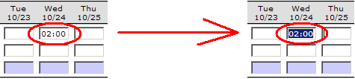
Fig. 1.24. Correcting time entries: select time entry to be deleted

- Use either the Backspace or Delete key on your keyboard to delete it:

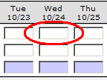
Fig. 1.25. Time entry deleted.

Or just type in the new entry if you are editing it:

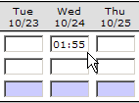
Fig. 1.26. Editing a time entry.

- Re-enter the correct amount just as you would any other time entry, or leave it blank if the entry needs to be left deleted. Note, again, that the totals won’t update until you complete the time entry.

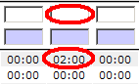
Fig. 1.27. Entry deleted, totals have not updated--needs to be completed by clicking elsewhere on the screen (or by running totals—see below).

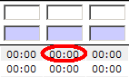
Fig. 1.28. Deletion complete—totals have updated.

- If you entered time under the wrong task, just delete the old entry or entries on that line. Then, click anywhere else on the screen, and the line will disappear. You can then create a new line for the correct task, and make the correct entry or entries.

Note: you cannot make changes to a timesheet after it has been submitted. If you need to make changes to a submitted timesheet, contact either your TL or the DCS Tenrox Processing Group.

Entering Notes on a Timesheet
Once a time entry has been made, you can add notes to time entries to provide additional information. There are two choices for entering a note for a time entry:

- You may either right click on a completed time entry and select the Notes option:

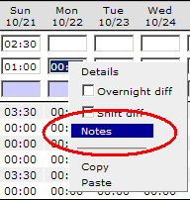
Fig. 1.29. Notes option.

OR:

- use Quick Notes at the bottom of the timesheet.
- If the Quick Notes box is not open, left-click on the plus sign (“+”) next to the words “Quick Notes”:

1.30. Click the Plus sign to open Quick Notes

- Left-click on the Blank Paper icon to open a new note:

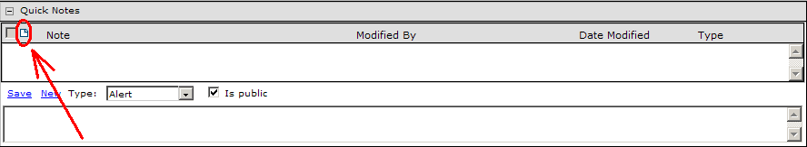
Fig. 1.31. The Blank Paper icon.

- Type your note in the box at the bottom of the page—a blinking cursor will appear inside it. When you are finished, click Save, and the note will appear (in blue) in the box above the bottom box.

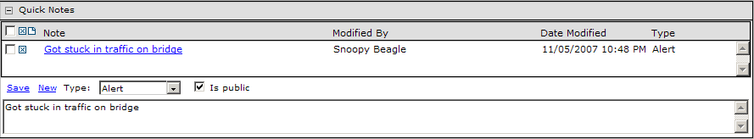
Fig. 1.32. A saved note.

- The time entry for that day will also turn yellow; this means there is a note saved for that time entry

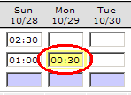
Fig. 1.33. This entry
has a note.

- To edit an existing note, double-left-click on the note that is to be edited. It will then be displayed in the bottom box, where you can make the needed changes. Once the note has been edited click Save.

Adding Your Own Timesheet Notes
Along with writing notes for individual time entries, you can write notes for entire timesheets. This may at times be helpful in conveying general information about a timesheet to a supervisor.

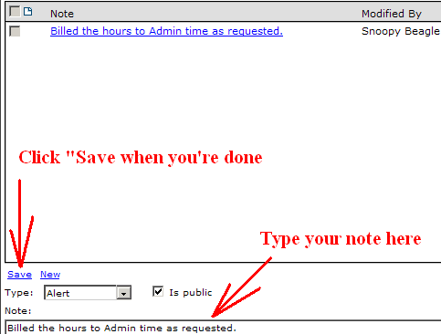
1.34. Writing general timesheet notes.

In addition, each time the status of your timesheet changes (each time you run totals, submit the timesheet, or it is rejected or approved), a note will be added here, as you can see from the list below.
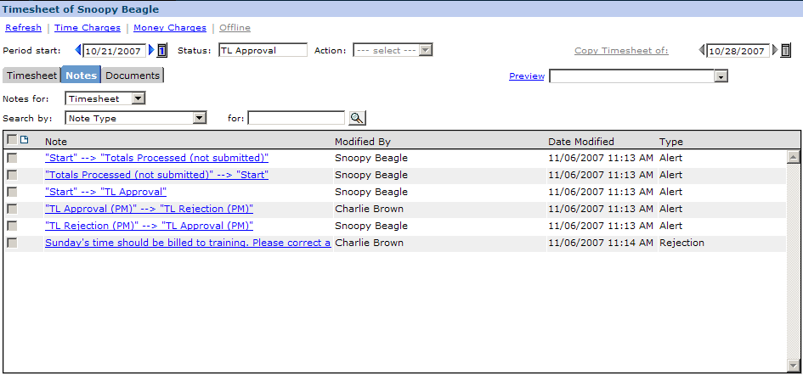
1.35. Timesheet Notes window

Running Totals
Run Totals will calculate your total hours entered and display any overtime on the timesheet. It will also show the number of hours to which your travel differential and shift differential apply. You do not need to use this action, but you may find it helpful to use from time to time. You can use the Run Totals option on the Action menu to add up your hours at any time.

- To use the Run Totals feature, click on the Action menu, and select “Run totals”.

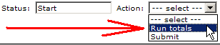
Fig. 1.36. Run totals.

You will see a certification message pop up: click “Yes” (you will see this certification message any time you change the Status of a timesheet).

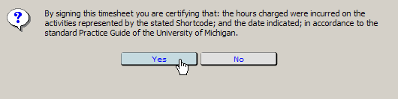
1.37. Timesheet certification.

The Status of your timesheet will change to “Totals Processed (Not Submitted)”:

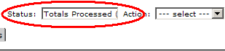
Fig. 1.38. Totals Processed status.

Note that when you run totals, your timesheet becomes locked, and you will be unable to make changes to it, unless you return it to Start status.

- To make changes to a timesheet after running totals, click the Action menu again. You will now see the option “Modify TS”:

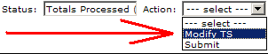
Fig. 1.39. Modify Timesheet (TS) option.

Click this option to unlock your timesheet. It will return to Start status, and you will then be able to enter time normally.

- If your timesheet is complete you may choose “Submit” to submit your timesheet for TL Approval.

Note that if you select Run Totals on an empty timesheet, you will see the message displayed on the screen, “There are no Tasks assigned for this period. Please click on the Assignments tab to assign tasks.”

Fig. 1.40. No Tasks Assigned screen.

In this case, this simply means that you have run totals on an empty timesheet. When you select “Modify TS” again, the message will disappear, and you will be able to enter time normally.

Submitting Your Time
Once you have completed your time entries for the week, you will be ready to send your timesheet into your team leader.

- To do this, you need to change the status of your timesheet to TL Approval. Click on the Action drop-down menu, and select “Submit”:

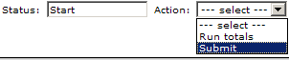
Fig. 1.41. Submit option.

- Tenrox will display the certification pop-up:

Fig. 1.42. Timesheet certification.

Click the “Yes” button to proceed. Once a timesheet has been submitted, “TL Approval” will be displayed in the status window.

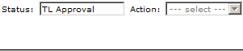
Fig. 1.43. Status changed to TL Approval.

The timesheet is now awaiting Team Leader or Production Manager review. Once approved, the timesheet status will be DCS approval. Once approved by DCS, the timesheet is sent to ISR payroll and the status will read Accounting Review. Once processed for payment, the timesheet status will be Closed. (Please see the Appendices for the approval workflow.)

Please enter your time each day, but only submit your timesheet once you have finished working for the week. Once it is submitted, you cannot revise it.

Timesheet Rejection
If a Team Leader or Production Manager reviews your timesheet and finds that corrections are needed, the timesheet will be rejected. You will receive an email telling you that your timesheet has been rejected. You should go into Tenrox and review this timesheet immediately.

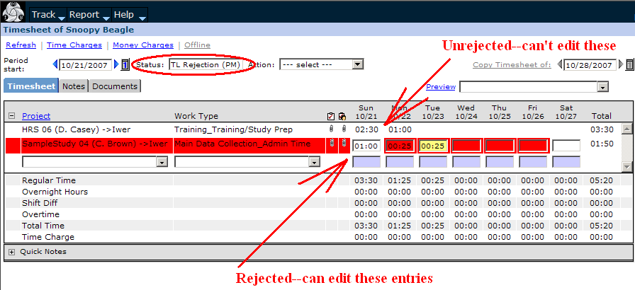
Fig. 1.44. Rejected Timesheet.

In this example, the employee is working on two projects. One Team Leader has approved the time submitted for her project, while the other has rejected the time for corrections to be made. Only the time highlighted in red can be edited.

Timesheet Notes
The Team Leader or Production Manager will enter a note on the Notes tab of your timesheet detailing the changes. To view the timesheet note, left-click on the Notes tab:

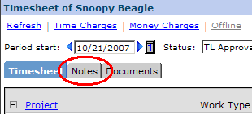
Fig. 1.45. Notes tab.

This will open the timesheet Notes window. To view the complete contents of a timesheet note, click on it, and it will display in the Note box at the bottom of the window:

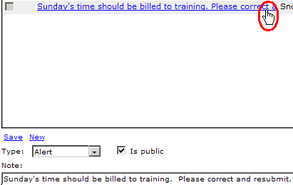
1.46. Timesheet Notes window

Editing and Correcting Submitted Timesheets
To edit a timesheet, simply perform whatever action requested. For information on editing and correcting a timesheet, please see the section “Deleting and Correcting Time Entries” above. If you are unable to edit a rejected timesheet, please email or call the DCS Tenrox Support Group for assistance.

Once corrections are made, you will need to click on the Action drop-down, where you will see the option “Complete Project”. Select this option to submit your timesheet.

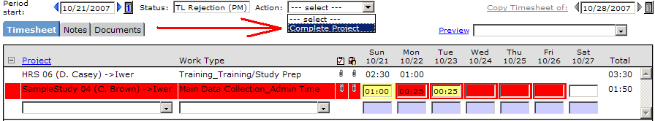
Fig. 1.47. Resubmitting a TL-rejected timesheet.

When you resubmit a timesheet, you will see a certification pop-up box.

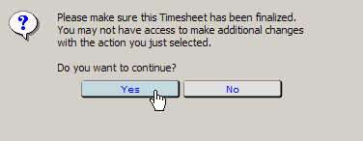
1.48. The resubmission certification message

Click “Yes” to resubmit. Once resubmitted, the status window will read TL Approval, and your timesheet will be sent to your Team Leader or PM for review.

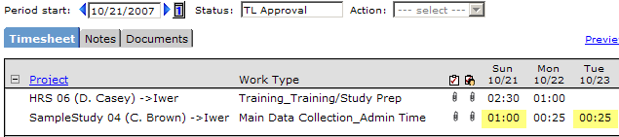
1.49. The resubmitted timesheet back in TL Approval status.

Editing and Correcting Multiple Projects
If you submitted time for more than one project, and the TLs for both projects rejected the time, all those lines will appear in red on your rejected timesheet:

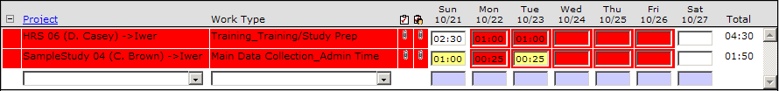
Fig. 1.50. Rejected lines in Timesheet.

Simply correct all lines in red as described in the above section, and re-submit.

DCS Rejection
From time to time, your TL will approve your timesheet, but it will be rejected by the approvers in the Ann Arbor office. When this happens, the process for editing and resubmitting is slightly different. When you open a DCS-rejected timesheet, you’ll see it with the Status of DCS Rejection, and the entries will not be highlighted in red.
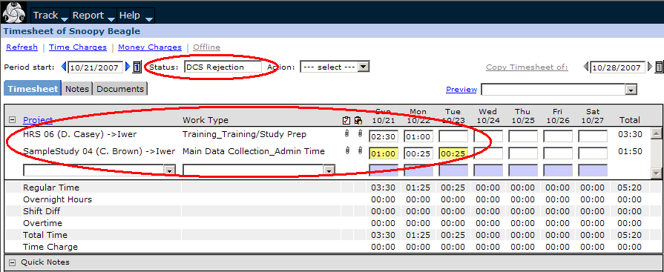
Fig. 1.51. Rejected lines in Timesheet.

This is because the entire timesheet has been rejected, and not just one project. Check the notes to see why DCS rejected it, and make the necessary edits and corrections. In order to make changes to a timesheet in DCS Rejection, you need to restart the timesheet first. You should not begin editing it directly until you have restarted it.

To restart the timesheet, click on the Action menu, and select the Restart option.

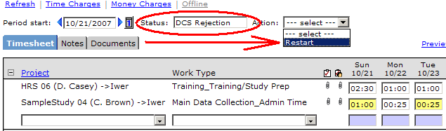
Fig. 1.52. Restarting a timesheet in DCS Rejection status.

Once the timesheet has been restarted, it will return to Start status. You can begin making edits and corrections. When you are finished, you will resubmit it by clicking on the Action menu, and selecting Submit.

Copying and Pasting Time Entries
You can copy and paste time entries.

- Right-click on a time entry to copy it; the entry will be highlighted in blue, and the options box will pop up. Click on “Copy” to copy the time entry.

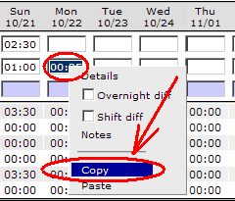
Fig. 1.53. Copying a time entry.

- Right-click on the time entry to which you want to copy the first one. The options box will then pop up, and you can then select “Paste” to paste the entry.

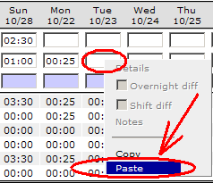
Fig. 1.54. Pasting a time entry.

A copy of the time entry will then be pasted into the selected entry box.

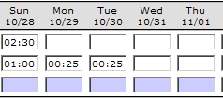
Fig. 1.55. A copied entry.

Copying Entire Timesheets
You can copy a timesheet from a previous week to the current week. The copy function allows you to quickly set up the project and work types you use most often. This feature should make your time entry faster and reduce your overall administrative burden.

- First, navigate to the week you want to enter time for (using the normal week-selection arrows and/or the calendar). In the upper left-hand corner, as usual, you’ll see the current start date (Sunday) of the week for the timesheet you’re viewing. In the upper right-hand corner, you’ll see the Copy Timesheet function. The date displayed defaults to the week prior to the current timesheet.

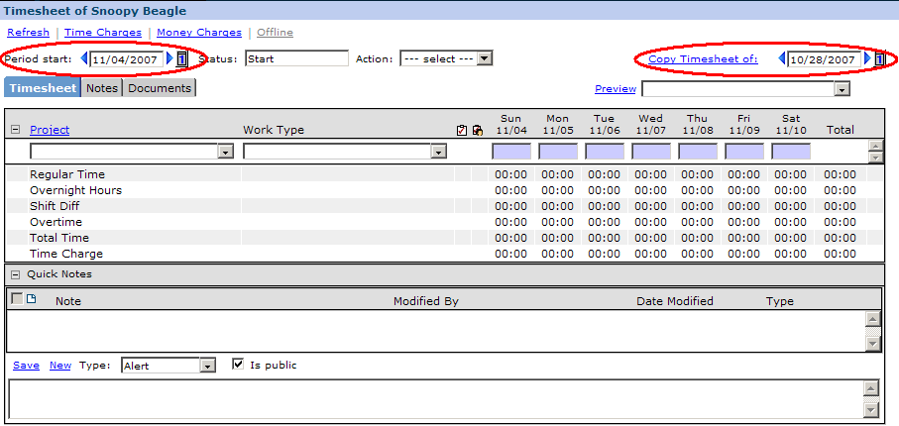
Fig. 1.56. The “Period start” date field and the “Copy Timesheet of” date field.

- You can likewise use the blue arrows (◄ ►) or the calendar button beside the “Copy Timesheet to” line to navigate to the week you want to copy. (Please note: If you wish to copy the past week’s timesheet, you will not need to change the date.)

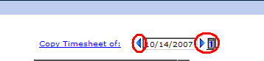
Fig. 1.57. The navigation controls for the “Copy
Timesheet of” date field.

- Once the start date of the week you want to copy appears next to “Copy Timesheet of”, left-click on the words “Copy Timesheet of”.

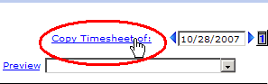
Fig. 1.58. Clicking on “Copy Timesheet of”
once the date has been selected for the
timesheet to be copied.

- The current week’s timesheet will become identical to the one you submitted on the date selected in the “Copy Timesheet of” field. Note that the “Copy timesheet of” box becomes greyed out; you can no longer copy a timesheet into a timesheet that already has entries in it.

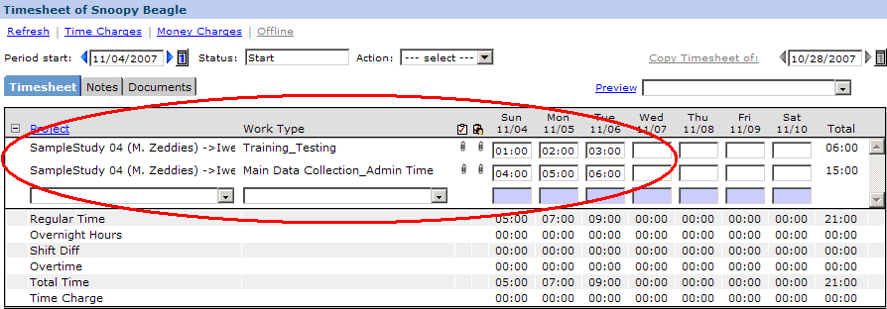
Fig. 1.59. A successfully copied timesheet.

- You will need to either replace or erase the copied time entries.

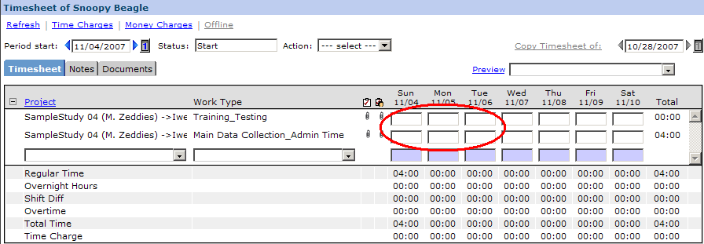
Fig. 1.60. Deleting the copied entries; the copied timesheet is now ready for time entry.

Do not copy weeks with holidays.

Entering Overnight Travel
If you are on overnight travel status, your hours have to be flagged as overnight travel on the timesheet. Overnight travel is defined as project-related travel that requires the interviewer to be away from home for two or more consecutive nights. To flag time as overnight travel:

- Enter the hours as usual, then right click on that time entry. The options box will pop up.

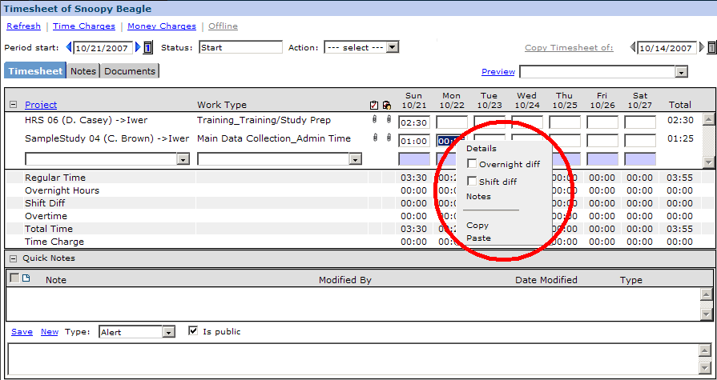
Fig. 1.61. Entering overnight travel time. Right-clicking on the time entry highlights it and displays the options box.

- To flag time as overnight travel, check the checkbox beside “Overnight diff”

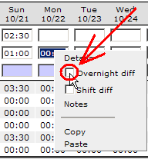
Fig. 1.62. The Overnight diff
checkbox

- The box will then disappear. Right-clicking on the time entry again will display it, this time with the checkbox checked:

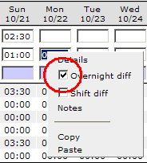
Fig. 1.63. The Overnight diff
checkbox checked

Remember, overnight travel is defined as two or more consecutive nights of travel.

The number of overnight hours you entered will not be displayed on the main timesheet page while you are entering time, but you can use the Run Totals action to display them (see the “Running Totals” above.) You can also display them by left-clicking the blue Refresh link at the upper left-hand corner of the timesheet view.

Entering a Shift Differential
From time to time, a project may authorize a shift differential for certain hours worked. You will be notified if this is the case. If you are receiving the shift differential, those hours have to be flagged as such on your timesheet. This process is very similar to flagging hours with an overnight differential. To flag time with the shift differential:

- Enter the hours as usual, then right click on that time entry. The options box will again appear.

Fig. 1.64. Entering a shift differential. Right-clicking on the time entry highlights it
and displays the options box.

- To flag time as a shift differential, check the checkbox beside “Shift diff” (similar to the Overnight diff example above).

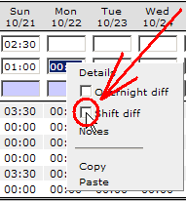
Fig. 1.65. The Shift diff
checkbox

- The box will then disappear. Right-clicking on the time entry again will display it, this time with the checkbox checked (similar to the Overnight diff example above).

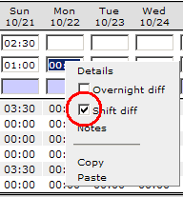
Fig. 1.66. The Shift diff
checkbox

The number of shift differential hours you entered will not be displayed on the main timesheet page while you are entering time, but you can use the Run Totals action to display them (see the “Running Totals” section below.) You can also display them by left-clicking the blue Refresh link at the upper left-hand corner of the timesheet view.

Timesheet submission summary

- Open up your timesheet to the appropriate week.
  - Tenrox with automatically set your period start date to the current week. Weeks run from Sunday-Saturday.
  - To access a previous timesheet, click on the blue arrow on the left side of the period start box.
- Select a project. (If it isn’t on the timesheet yet)
- Select a work type. (If it isn’t on the timesheet yet)
- On the line for each work type, left-click on the box under the date for which you want to enter time.
- If necessary, add a Note.
- Repeat steps 2-4 as necessary.
- At the end of the week, submit your timesheet by selecting “Submit” from the Action menu.

Section 2 -- Expense Reports

Expense Report display
All expense entries and requests for travel advances are entered in the expense module of Tenrox. To enter the expense section of Tenrox:

- Go to the top row, click Track, and then click Expense.

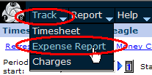
Fig. 2.1. Expense module.

You have entered the Expense section of Tenrox. The top section will look like this:

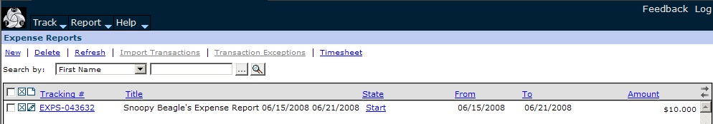
Fig. 2.2. Expense section.

Note the line of blue links beginning “New,” “Delete,” etc. You’ll use these to create and update expense reports.

The next line is the “Search by” line. Once you’ve created expense reports, you’ll be able to use this line to search for expense reports by category.

Finally, you’ll see column headings, again as blue links, labeled “Tracking #,” “Title,” etc. You’ll be able to use these to sort expense reports.

(Please also note the little grey arrows at the far right-hand side of the grey bar—these will allow you to scroll by page once you’ve entered more expense reports than the screen can display. This will also be covered later.)

All of your expense reports are listed here. Also note the scroll bar at the right-hand side of the screen. Once you’ve created several expense reports, you’ll be able to use this scroll bar to scroll up and down the list of expense reports.

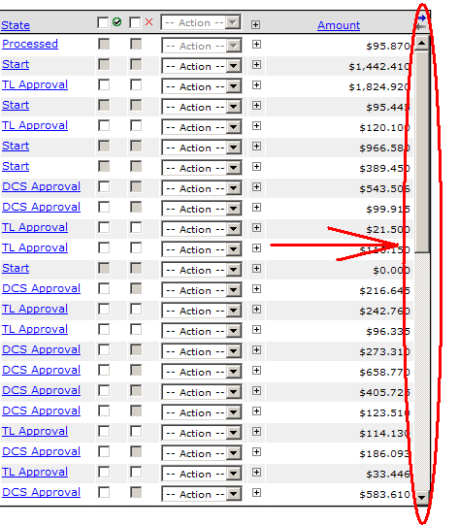
Fig. 2.3. Scroll bar in Expense section.

Creating a New Expense Report
Once you enter the Expense section you may either create a new expense report or edit an existing expense report. To create a new expense report:

- Either left-click on the “New” link, in blue at the upper left-hand corner of the page, or click on the “new page” symbol—it looks like a little piece of paper with a corner folded down.

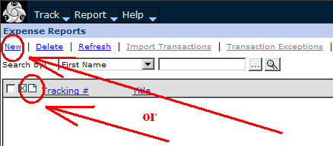
Fig. 2.4. Creating a new Expense Report.

This will create a new Expense Report pop-up window:

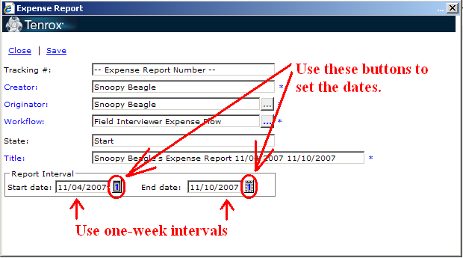
Fig. 2.5. Expense Report window.

The Title of the expense report will be automatically filled in with your name. The only information you have to enter in this box are the Start and End dates of the report, which you will see at the bottom of the window. These dates are determined by the dates of the expenses you plan to submit on the report.

- In general, your expense report should mirror your pay week dates. So, usually the Start date will be a Sunday of a particular week, and the End date will be a Saturday of that same week. An exception might be for travelers who make the expense report data match the dates of their trip.

To select the dates, click the little calendar buttons (similar to the ones on the Timesheet page). next to each date:

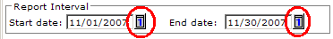
Fig. 2.6. Calendar buttons.

A calendar box will pop up, just like the one in the Timesheet section. Once you select the dates from the calendar, the Title of the expense report will automatically be updated. Remember, expenses are entered daily, but submitted weekly.

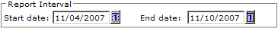
Fig. 2.7. Clicking on Details.

Please do not edit the Title section of the expense report, or any of the other fields.

- After you have entered the start and end dates, Save the expense report (a).

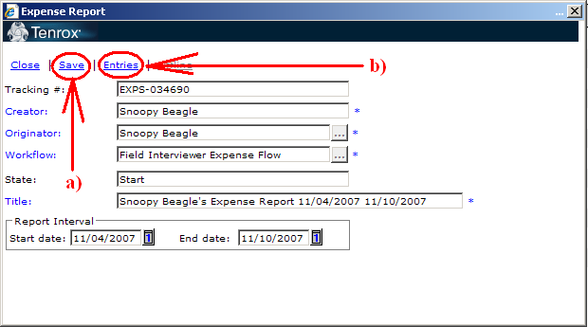
Fig. 2.8. Save and Entries links.

Once the expense report has been saved the dates cannot be changed. If you make an error with the dates, you will have to close this window, delete the expense report, and start over again. Please see the instructions on deleting an expense report for assistance.

Note that once you Save the new expense report information, a unique Tracking number will be automatically created for the expense report, and an “Entries” link will be added to the window (b).

All expense reports begin with EXPS.

If you find you have expenses for a week that you have already submitted an expense report for, and you did not include them on the report, and it has already begun the approval process, include them on the expense report for the next week, but extend the start date of that report back to include the expenses for the previous week.

If you are working on more than one project, you must create separate expense reports for each project. As you will see below, Tenrox will not permit you to place expenses for more than one project on an expense report.

Once the expense report has been created you are all set to enter expenses on the report. To enter expenses:

- If you have just created the report, left-click the word Entries from the Expense Report pop-up window. This will take you to the expense data entry screen.
- You can also close the pop-up window at this point by clicking the Close link, which will return you to the main Expense page. You will then see the expense report number listed (along with any other reports you have created:

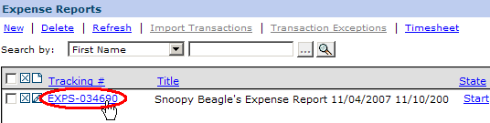
Fig. 2.9. Expense Report list.

- To open an expense report from the main Expense page, find the expense report number you want from the list, and click on the expense report number itself (as indicated by the arrow). This is the way you will normally open an expense report, if you are adding expenses as you go through the week. Each time you need to add an expense to a report that you have created, you will open it in this manner.

Adding a New Expense Entry

- Click on the “New” link at the upper left-hand corner, or the new page icon (just like on the main Expense Report section) every time you want to enter an expense on an expense report.

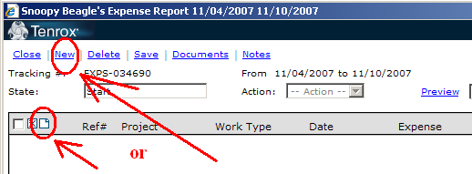
Fig. 2.10. New link for entering an expense.

Note: if you are ever in doubt about the functionality of an icon, move the mouse-cursor over it and wait a few seconds; you may see a pop-up tooltip that explains the function of the icon.

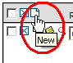Fig. 2.11. The tooltip for the New Entry icon.

The title of the expense report is displayed on the top bar. Again, you will not be able to enter expenses that don’t fall within the dates of the report (if you try, Tenrox will remind you.)

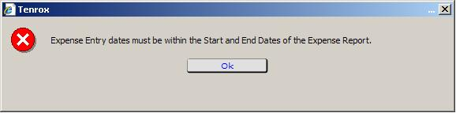
Fig. 2.12. Popup reminder, when you try to enter an expense for a date outside the
range for the report.

You will now find that entering expenses is very much like entering time on a timesheet.

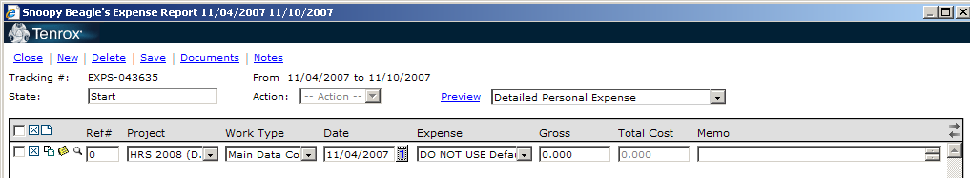
Fig. 2.13. A new expense entry.

- The next step is to select a Project. The Project field defaults to the first project alphabetically on the list of projects assigned to you.

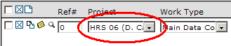
Fig. 2.14. Selecting a project.

- If you are assigned to more than one project, you will need to click on the Project drop-down menu if you need to change the project, by clicking on the Project drop-down menu, and clicking on the desired project from the list.

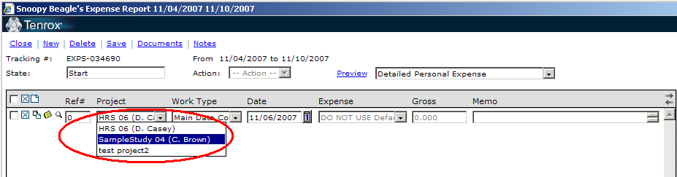
Fig. 2.15. Project drop-down menu

If you are entering expenses for more than one project, you will need to create separate expense reports for each project.

Once you choose the project for an expense on an expense report and save it, Tenrox will only allow expenses from that project on the expense report. In order to enter expenses for another project, you will have to create another expense report. This is true even if you delete all expenses from an expense report—Tenrox will remember what project they were for, and will only allow expenses from that project on that report.

- Next, you need to select a work type.

The Work Type box is initially filled in with only a placeholder, like “Main Data Collection.” You cannot leave this default as is. You must manually select a Work Type (“Main Data Collection_Production,” for example). Click on the Work Type field or the arrow to get the drop-down menu, and make your selection from there.

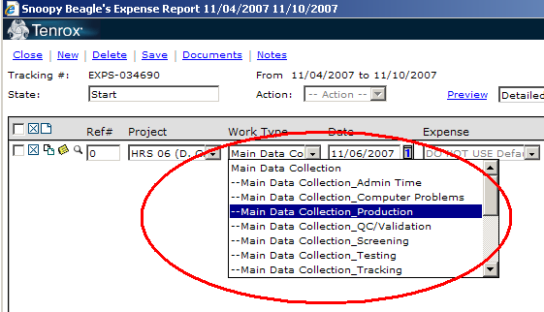
Fig. 2.16. Selecting a work type from the Work Type drop-down menu.

Once you’ve selected the work type, you’ll notice that a double-hyphen will appear in the Work Type field. This means a specific work type has been selected.

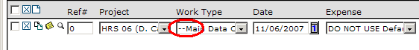
Fig. 2.17. The double-hyphen denotes that a specific Work Type has been
selected.

Note that like the timesheet, the expense report fields may not be large enough to display the entire text within the field. Like the timesheet, you can always use the tooltips to view the entire text.

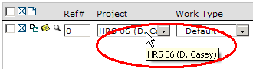
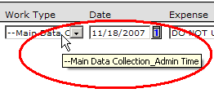
Fig. 2.18. The Project and Work Type field tooltips.

- Next you will need to enter the Date associated with the expense. Click on the calendar button beside the date listed

  - The Date field defaults to the current date.
  - If you need to change the date, click on the calendar button beside the date field.

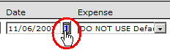
Fig. 2.19. Date selection calendar button.

You’ll get a pop-up calendar. Click on a date, and you’ll be returned to the Expense Report screen, where you’ll see the new date displayed.

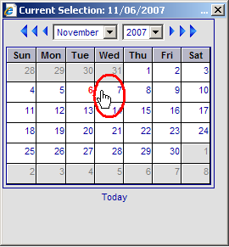
Fig. 2.20. Choosing a different date.

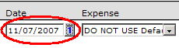
Fig. 2.21. The Date has been changed.

  - Your date must fall within the dates selected when the expense report was created. If you try to save a report with dates outside of the expense range you will receive an error message in a pop-up box.

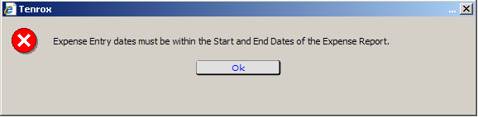
Fig. 2.22. Date selection error.

If you get this message, click Ok on the pop-up box to clear the message, then change the date before saving.

  - If the expense date falls outside of the dates of the report you will have to create a new expense report, and submit the expense(s) on that report.

- Next you need to enter the Expense type.

  - Note that if you do not select a Work Type, you will not be able to select an Expense type. If Tenrox is not letting you select an Expense type, i.e., the selection box is grayed out, you need to go back and pick a Work Type first

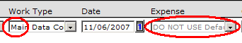
Fig. 2.23. The Work Type here has not been selected.

  - Note also that once you pick the Work Type, the Expense box initially says “DO NOT USE Default.” This means that this is only a default placeholder, and you should not use it. You must select an Expense type for every expense yourself. Click on the Expense field or the arrow to get the drop-down menu. This will take you to the list of expense types.

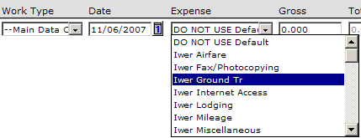
Fig. 2.24. The Expense type drop-down menu.

  - If you are an Interviewer you will select from the codes labeled “Iwer.” Likewise if you are a Team Leader you will choose from the codes labeled “TL.”

- Once you have selected the appropriate expense category, enter the dollar amount of the expense in the box labeled “Gross.” The only exception is for a mileage entry, which we’ll discuss shortly.

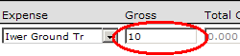
Fig. 2.25. Entering the expense amount.

Some expenses require that information be entered in the memo field. Please refer to Appendix 3 to see which expenses require memos. We’ll cover how to enter memo information in the next few sections.

When you’re completely finished entering an expense, Save the expense report by clicking the Save link at the top. You should click Save after you enter each line.

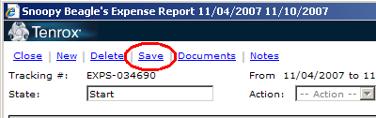
Fig. 2.26. The Save link.

Note that if you do not enter an amount for the expense in the Gross box, you will get an error box:

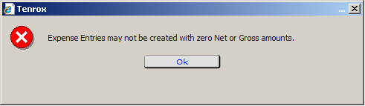
Fig. 2.27. The error message when saving an expense without an amount.

Make sure to enter the amount of the expense directly into the “Gross” field (unless it is for a mileage entry, which we will now cover.)

Mileage Expenses
Mileage entries are begun just like other expenses—so, to review:

- Create a new expense line, using either the link or the icon
- Select the project
- Select the work type
- Enter the date
- Enter the expense type—“Iwer Mileage”

You will then be taken directly to the Expense Entry Edit window.

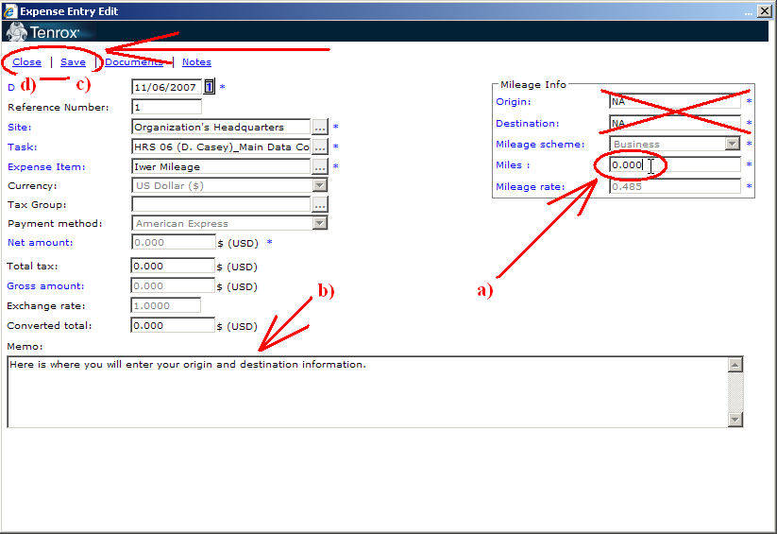
Fig. 2.28. The Expense Entry Edit screen.

Enter the miles driven into the Miles field, on right side of the window (a). Don’t use the Origin and Destination fields; you’ll be entering that information into the Memo field.

You will now need to enter additional information in the Memo field (b). You must fill in the Memo field with the origin of your journey, as well as the destination, and major points in-between.

- For example, if you traveled from your home to Ann Arbor, and back home again, you would enter “Home to Ann Arbor to home.” You may also use the abbreviation “RT” for “round trip,” like so: “RT home to Ann Arbor.”

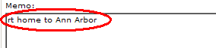
Fig. 2.29. Memo for a round-trip between two locations.

- If you traveled within your segment, you might enter “Home – Miami – driving to many HU’s– Home” (for example).

- You can also use major points such as “Ronald Reagan airport” or “northern Detroit suburbs.”

Basically we just need the travel described in some sort of complete manner, describing or at least summarizing all the points you visited.

When you are finished entering the mileage and memo, (c) click “Save” then (d) “Close”. (If you don’t click “Save” first, and you’ve entered mileage or memo information, you’ll get the confirmation popup.) Tenrox will automatically calculate the dollar amount, and display it on the expense report line for the expense, along with the Memo text.

Fig. 2.30. A successfully-entered Mileage amount.

Changing Mileage Entries
If you need to edit the mileage for a mileage entry after you’ve saved it, click on the magnifying glass icon near the beginning of the mileage expense entry (beside the Ref #)/

Fig. 2.31. The magnifying glass—mileage entry edit.

This will re-open the Expense Entry Edit screen, where you can re-enter the mileage or edit the memo as needed. (Don’t forget to save before closing the Expense Entry Edit screen.) You can also edit a memo this way, or directly from the expense entry line.

Gross and Total Cost Amounts for Internet Partial Expenses
For all expenses besides Internet Partial expenses, you will not have to enter anything in the Total Cost field—it will remain grayed-out. For Internet Partial expenses, you will have to enter the established reimbursement amount for Internet bills in the Gross field, and the total cost of the bill in the Total Cost field.

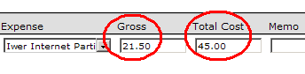
Fig. 2.32. Entering Gross and Total Cost amounts
for an Internet Partial expense.

Entering/Editing Memo Entries Directly From an Expense Entry Line
You may need to enter memos for other time entries. You can enter them directly into the Memo field on the expense entry line, by clicking on the Memo field and typing them in. You can also edit them directly, by clicking on them and typing and deleting as needed.

Fig. 2.33. Entering/editing a memo directly onto an expense entry line.

If the text entered in a Memo field is longer than the display area it will wrap (as you can see in the example above). In that case, click on the magnifying glass, as shown above, to open the Expense Entry Edit window and view the entire text of the memo.

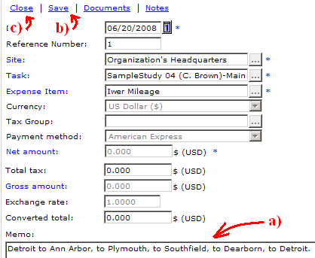
Fig. 2.34 Entering a Memo from the Expense Entry Edit screen.

From there, you can (a) click directly on the text to edit it. When you are finished, (b) click Save, and then (c) Close.

Copy Button
Each line on an expense report has a Copy button that can make it much easier to create expenses. The Copy button is the icon on the left end of the line that looks like two tiny pieces of paper stacked on top of each other:

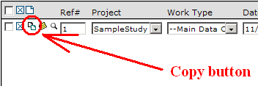
Fig. 2.35. Copy button.

To copy a line, click on this icon. This will create a duplicate of that line.

Fig. 2.36. A copied line, waiting to be edited.

You may then change the necessary fields. Note that if you copy a mileage line, you’ll immediately be taken to the Expense Entry Edit screen, where you can adjust the mileage and memo information as needed. Try to copy a line that is the most similar to the type of expense you need to enter, to minimize the number of changes you will need to make to it.

Adding Notes to Expense Reports
You can enter general notes for an expense report, just as you can for a timesheet, by clicking on the blue “Notes” link at the top of the expense report.

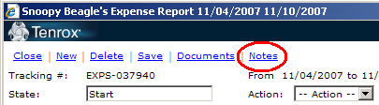
Fig. 2.37. The Notes link for general expense report notes.

You’ll be taken to the Note Entries window, where you can write, save, edit, and view notes.

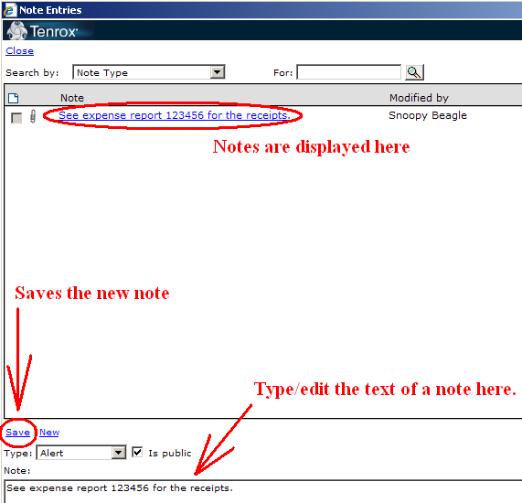
Fig. 2.38. The Note Entries page for expense report notes.

Please be sure never to include confidential information such as Respondent name, zip code or address.

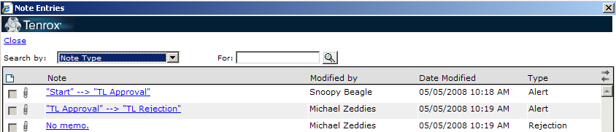
Fig. 2.39. Status changes in the Note Entries window.

When an expense report changes status, a note is entered into the Note Entries window, recording the change of status (“Start” “TL Approval”, for example).

Copying and Pasting Notes and Memos
Notes and memos may be blocked, copied and pasted to save time. To block a note or memo, click at the beginning or end of the text you wish to edit, hold the left mouse button, and move the cursor until the text you wish to copy is highlighted. Release the left-click button. Hit the “Ctrl” key on the keyboard and the letter “c” at the same time (Ctrl-C). This will copy the text. Move your mouse to the place where you want to place the information, left-click then hit the “Ctrl” key and the letter “v” at the same time (Ctrl-V); this will paste whatever you copied in the new location. You can also use the right-mouse-button menu to do the same thing.

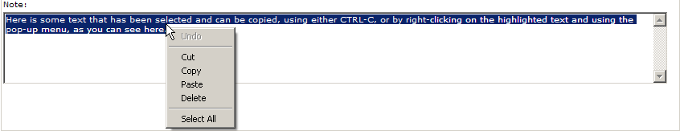
Fig. 2.40. Selecting (and right-clicking) the text of an expense report note.

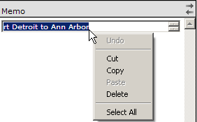
Fig. 2.41. Selecting (and right-clicking)
the text of an expense entry memo.

To select the text of a memo longer than the field will display, simply keep the left mouse button depressed, and move the cursor up and down as needed, until the entire text is highlighted.

Per Diem information
If you select per diem as the expense type, you must enter a note in the memo field for each per diem claimed. The note must include the destination, the start and end dates of the trip, and the per diem location selected for the per diem rate.

- If you were traveling to Detroit, Michigan from June 12, 2008 – June 18, 2008 your note might look like this:

Detroit, MI 6/12 – 6/18, per diem=Detroit, MI

Fig. 2.42. The beginning and end of a Per Diem memo (scrolling down to
view the entire text).

Per Diems for Lodging (i.e., Hotel Bills)
Please note that all lodging charges for an expense report should be included in a single line. Don’t create a separate line for each day.

If you have a per diem entry on an expense report, but do not have a lodging expense on that same report, please leave a note, in Note Entries explaining how the lodging will be billed.

- If, for example, you stayed at a friend’s house, your note would read “no charge for lodging—stayed w/ friend.”

- If your lodging will appear on some other expense report, please provide the expense report number (the EXPS number) in your note. For example: “Lodging will appear on EXPS-175829”.

- If your lodging was paid by the U of M, please note this by saing “no lodging expense—paid by U of M”.

Deleting an Expense Entry
From time to time you may need to delete an expense entry line off a report. You can do so by clicking on the little “X” in a box on the left-hand end of the line, right next to the copy button:

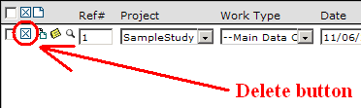
Fig. 2.43. Deleting an expense line.

Tenrox will then ask you if you’re sure you want to delete it:
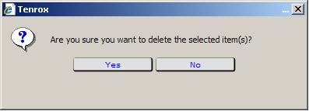
Fig. 2.44. Deletion verification box.

Answer “Yes” or “No” as appropriate.

Note that if you have created a new expense entry, and try to delete it before saving the report, you will receive the following message:

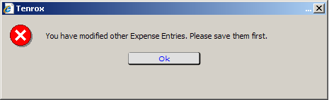
Fig. 2.45. Deletion verification box.

You must click “Ok”, in which case you will be returned to the expense report, where you will have to click “Save” first, then delete the entry.

Expense Entry checklist
- Create a new expense report, unless you already have one in “Start” status for that week and project.
- Open the expense report.
- Click “New” or the new page icon to create a new expense line.
- Select a project (remember, only one project is allowed per report).
- Select a work type.
- Enter the date for the expense.
- Enter the expense type.
- Enter the dollar amount of the expense.
  - If entering mileage, enter the mileage on the Expense Entry Edit screen.
- Enter any needed memos.
  - If entering mileage, enter the memo on the Expense Entry Edit screen, and save.
- Save the expense report.
- Repeat steps 3-9 as necessary. Use the “copy” and “delete” features as needed. Edit expense entries as needed.
- Save the expense report one more time.
- If you are finished with all your expenses for the period and project, submit the expense report. Otherwise, close it, and return to it later.

Don’t forget to use the copy feature; it is a real time saver!

Submitting the Expense Report
Once you have finished entering expenses, save your expense report. You may now close the report or submit it for Team Leader approval. Please do not submit your report until it is final; once submitted you will not be able to make any edits. Like timesheets, expense reports are due weekly.

Again, there is no limit to the number of expense reports you can submit, but we ask that you work as efficiently as possible. Your Team Leader/Production Manager and staff in Ann Arbor have to review all expense reports submitted so try to include all your expenses per project in one expense report each week.

To submit your expense report, select Submit from the Action box.

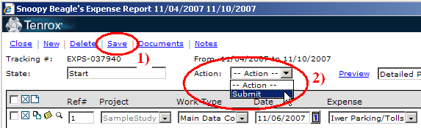
Fig. 2.46. Expense Report submission.

You will see a certification message:

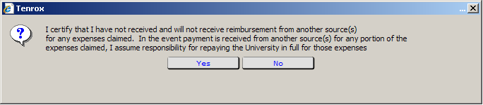
Fig. 2.47. Expense Report certification message.

Click “Yes” to certify your expense report.

Once submitted the State of the expense report will read TL Approval. The Action menu will also be grayed out.

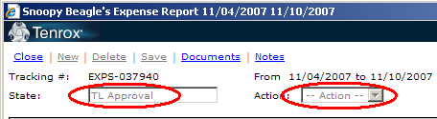
Fig. 2.48. Expense report in TL Approval.

It will also appear in TL Approval on your expense report list.

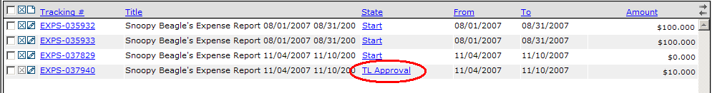
Fig. 2.49. An expense report in TL Approval on your expense report list.

See the Expense Report workflow (Appendix 5) for a detailed overview of the approval process.

R Payment Paperless Expenses
If you select the R Payment Paperless expense type, you must type in the SID of the interview for which the respondent received payment.

Fig. 2.50. An R Payment Paperless expense entry; the SID must be included.

Expense Report Rejection
If a Team Leader or Production Manager reviews an expense report and finds that corrections are needed, the expense report will be rejected. You will receive an email notification saying that your expense report has been rejected. You should review the rejected expense report immediately. To review, view your list of expense reports from the Expense Report view in Tenrox. You’ll see the reports that have been rejected. Click on the expense report number (the EXPS number) of the expense report to open the expense report.

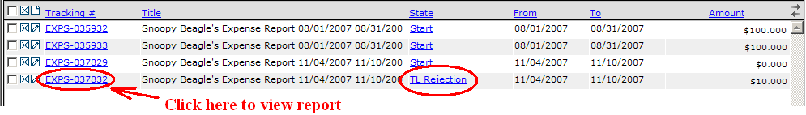
Fig. 2.51. An expense report in TL Rejection on your expense report list.

The Team Leader or Production Manager will enter a note on the expense report detailing the necessary changes, so you should view the notes first, by clicking the “Note” link at the top of the page. (see Fig. 2.26 above).

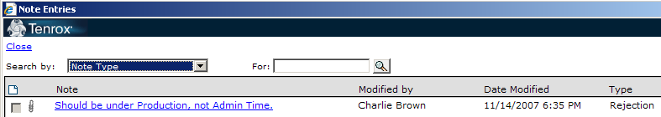
Fig. 2.52. Viewing rejection notes for an expense report.

In order to edit your expense report, you will have to Restart it.

To restart your expense report:

- Make sure you have opened the expense report and are viewing it. (If you’re viewing the notes, close the Note Entries screen.)
- Click on the Action menu, and select Restart.

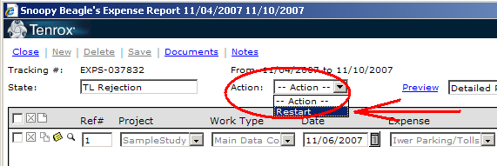
Fig. 2.53. Restarting an expense report.

- Note that you will see another certification message.

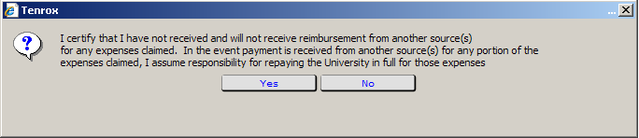
Fig. 2.54. The expense report restart certification message.

Click “Yes”. You will then be able to edit your expense report.

- Once corrections are made, go to the Action window and submit the expense report again. Once resubmitted the status window will read TL approval and the approval process is restarted.

Questions about expense report corrections and rejections should be directed to the appropriate Team Leader or Production Manager.

Editing an Existing Expense Report
Again, to re-enter an expense report that has been saved but not submitted:

- Return to the Expense section of Tenrox (by clicking on Track, then Expenses.)
- From the list of expense reports, left-click on the tracking number (the EXPS number) of the expense report you wish to edit. This will open up the expense report on your screen, and you may now edit an existing entry, or add additional expense entries.

Note that prior to submission of an expense report, you can change any of the fields (except for Project) of an individual expense if you have made an error. To change an entry, just re-enter the expense report, and click on the drop-down menus for the expense you need to change.

Sorting Your Expense Reports
You can sort your list of expense reports. At the top of the list is a grey bar with column headings. Normally your expense reports are sorted by expense report number, in ascending order. Clicking on a heading first sorts by that category, in ascending order (unless it is already ascending), then by descending order.

Fig. 2.55. Sort options.

So, for example, here are expense reports sorted in ascending order:

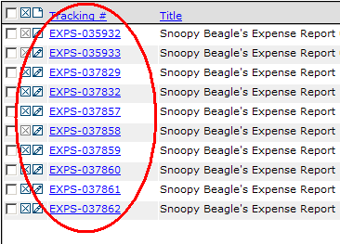
Fig. 2.56. Sorted by Tracking #, in ascending order.

And here they are in descending order, after clicking on the “Tracking #” heading:

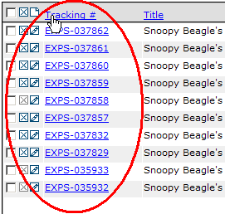
Fig. 2.57. Sorted by Tracking #, in descending order, after
clicking on the “Tracking #” column heading.

This can be very helpful if you are searching for your most recent expense reports, for example—reversing the order of the Tracking numbers will put the most recent reports first, as will reversing the “From” and/or “To” order.

Paging Through Your Expense Reports
You will notice some tiny arrows at the far right-hand end of the grey bar (scroll the screen over to the far right if you can’t see it):

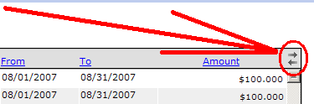
Fig. 2.58. Arrows for paging through expense reports.

Tenrox can only display 50 report lines on the screen at once. If you have created more reports than that, Tenrox will put some of them on an additional screen. If this is the case, the top arrow will turn blue, and you’ll be able to click it to view the remainder of your expense reports

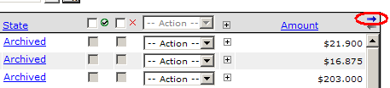
Fig. 2.59. Once you have more than 50 reports, the top arrow will
turn blue.

After you have paged forward, the bottom arrow will then turn blue so you can return to the original page.

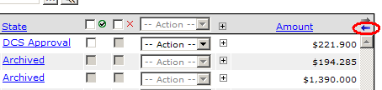
Fig. 2.60. Once you have paged forward, the bottom arrow turns
blue as well.

Once you’ve created more than 100 reports, the middle pages will display both arrows in blue.

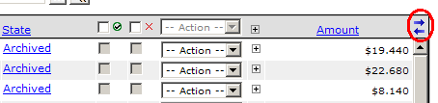
Fig. 2.61. Both arrows are blue: there are multiple pages of reports.

Deleting an Expense Report
If you need to delete an expense report, left-click on the “X” to the left of the tracking number from the main Expense section page:

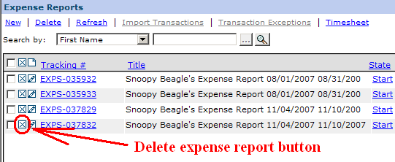
Fig. 2.62. Deleting an Expense Report.

Again, Tenrox will ask you if you’re sure you want to delete the line; click on “Yes” or “No” as appropriate. You can only delete reports that are in the “Start” status. If a report has been submitted and needs to be deleted, please contact the DCS Tenrox Processing Group.

(You can also check the checkbox next to the “X”, for as many expense reports as you need to delete, then click either the “X” at the top of the column, or the blue “Delete” link near the top of the page.)

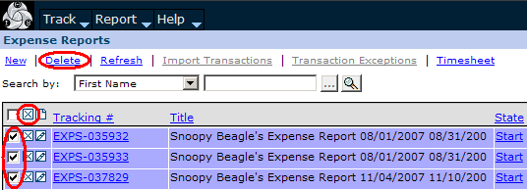
Fig. 2.63. Alternate ways of deleting an Expense Report.

Remember, if you are ever unsure of the function of an icon, use your mouse to place the cursor over the item, and you’ll see a pop-up tooltip for that icon.

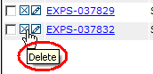
Fig. 2.64. A tooltip.

Other Expense Section Features
Let’s return to the main Expense section page. You’ll recall that the first line in this section contains some blue links, the first of which we have already used: “New.”

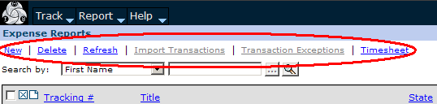
Fig. 2.65. Additional links in the Expense module.

We’ve covered “New” and “Delete” above. The “Refresh” link can be used to refresh the expense report display, just as with the timesheet display. After you have entered data and saved you can click it to re-display the page, to include the changes you have just made, if they are not immediately visible.

“Import Transactions” and “Transaction Exceptions” are grayed-out and are unusable.

The “Timesheet” link will return you to your timesheet.

Returning To the Timesheet View, and the Charges Tab
You can return to the Timesheet view by moving the mouse-cursor over the Track tab, then selecting the Timesheet option from the drop-down menu.

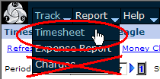
Fig. 2.66. Access the timesheet module.

Note the Charges option; you won’t need to worry about this unless further directed.

Travel Advances
Travel advance requests are also made in the Expense module of Tenrox. To enter the expense module of Tenrox, go to the top row and click Track then click Expense, just as you would for an Expense. To create a new travel advance request, click on the New icon or on the “New” link at the top of the page.

To request a travel advance you must change the workflow to travel advance. When you get the expense report pop-up box:

- Click on the button with the ellipses in it (i.e., the three little dots, “…”) to the right of the Workflow line.

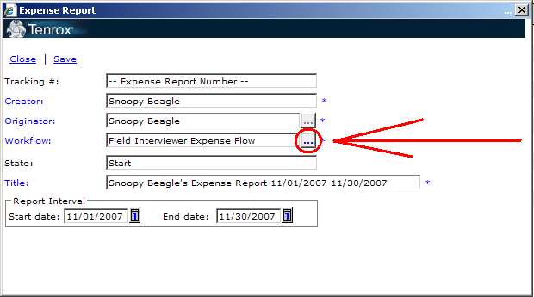
Fig. 2.67. Creating a Travel Advance.

You will then get the list of Expense Workflows.

- Click on the one that says “Travel Advance Workflow.”

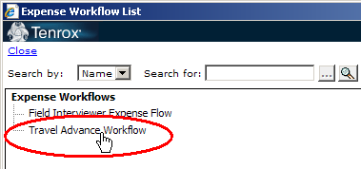
Fig. 2.68. Travel Advance Workflow selection.

If you forget to change the workflow, you will create a new expense report instead of a travel advance request. Delete the expense report and begin again. (Left-click on the X to the left of the tracking number to delete it.) Again, if you are unsure of the function of an icon, use your mouse to place the cursor over the item. If you let the pointer rest on an icon the function or purpose will be displayed.

The only information you will have to enter is the Start and End dates of the trip.

- Enter the start and end dates of the trip.

Once you select the dates, the title of the travel advance request will automatically be updated with the dates and your name. Just as with expense reports, please do not edit the title section of the travel advance request.

- After you have entered the start and end dates, save the travel advance request

Once the travel advance request has been saved the dates cannot be changed. If you find you have made an error delete the travel advance request and begin again.

Each time a new travel advance request is created it will be assigned a unique tracking number. You will notice that the travel advance tracking numbers begin with TRAW.

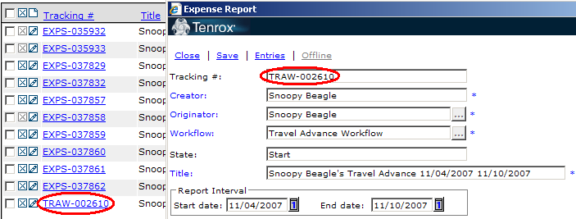
Fig. 2.69. Travel Advances.

You are all set to enter the expense on the travel advance request. This is identical to the process for entering expenses for an expense report.

All travel must be pre-approved by your Team Leader and/or Production Manager.
Please remember that if you are traveling, your Memo field for all Per Diems must contain the following:

- start and end dates for the trip,
- the destination, and
- the Per Diem for the chosen city

As with expenses, you should only enter one line for lodging expenses. Do not enter a line for every day of lodging; just add up the total lodging costs, and enter it on one line. Please see the Per Diem section above for additional instructions. The Per Diem rules for travel advances are identical to those for expense reports.

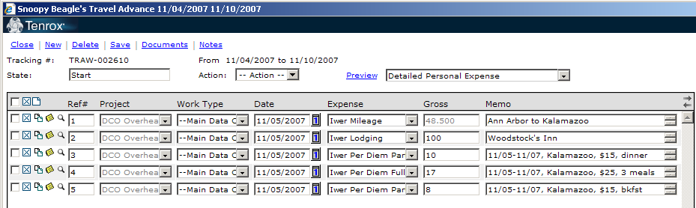
Fig. 2.70. Travel Advance example.

Once the travel advance request has been completed, save it, then submit it for Team Leader Approval. See the Travel Advance workflow (Appendix 5) for a detailed overview of the approval process.

Note: travel advances are listed together with expense reports. They can be rejected, restarted, opened, viewed, edited, and resubmitted just like expense reports. They are also sorted at the end of the expense report list in ascending order, and at the top in descending order.

Reimbursement Processing
Once an expense report is approved for reimbursement, an email is automatically generated. If there is an outstanding Travel Advance balance, the reimbursement is subtracted from the balance due. If there is no outstanding Travel Advance balance, then on the next reimbursement date, either a check will be cut and sent to you, or it will be deposited into your account, based on the same options you have selected for method of payment for your payroll checks. Expenses are processed on a rolling basis and are reimbursed three times a week. Please allow a minimum of 2 weeks for an expense report to be fully reviewed and processed and them an additional few days for postal delivery, if your option is payment via USPS.

Exiting Tenrox
To end a session left-click on Log Off in the upper right-hand corner of the main screen. (NOTE: Remember not to not use the Feedback link.)

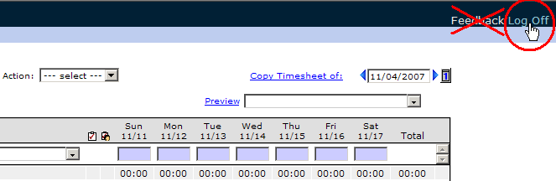
Fig. 2.76=1. Logging off Tenrox.

You’ll see a logoff confirmation box pop up.

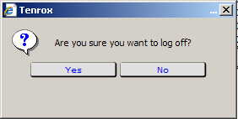
Fig. 2.72. Logoff confirmation.

Click “Yes” to exit Tenrox, then close the window by clicking the X in the upper right-hand corner of the screen.

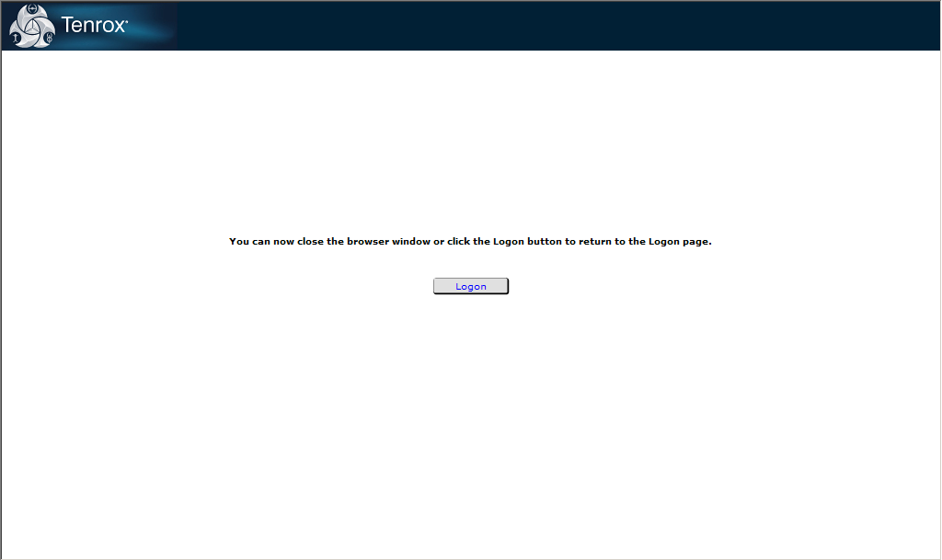
Fig. 2.73. Bye Snoopy!

If you have questions about Tenrox, or encounter any unexpected events when using it, contact your Team Leader or Production Manager. If this does not resolve the issue, contact us by email by typing in “DCO Tenrox Processing Group” in the To field of your email (or you can type in the actual email address: dcstenroxprocessinggroup@isr.umich.edu) Please also feel free to call us at 1-800-321-7104, option 2.

Section 3 -- Interviewer Payroll and Expense Guidelines

Tenrox
Tenrox is the software used to record interviewer hours, report expenses and request travel advances. It is your responsibility to keep these records for time and expenses and to submit them in accordance with the current pay schedule.
(Appendix 1).

Collective information from Tenrox keeps your project team up-to-date about interviewing costs. Additionally, statistics from Tenrox help Supervisors evaluate individual interviewer performance.

Reporting Time
This section covers the general instructions for receiving payment for your time and expenses. Please ask for clarification of procedures from your Supervisor anytime it is needed. A step-by-step user’s guide to Tenrox follows.

- Enter data into your Tenrox timesheets and expense reports every time you work. This will help to insure accurate and timely data.

- It is important to keep track of your time on a daily basis. At the end of each day total the time spent, select the appropriate work type(s) that correspond to the work you performed and enter this on your Tenrox timesheet.

- You are paid on a bi-weekly basis, but your timesheets are due once per week. Your Supervisor has to have all interviewer timesheets reviewed and finalized by the end of the day Tuesday. Your Supervisor will work with you to establish a weekly deadline.

- If you are active on a project but do not work any hours in a pay week you may be asked to submit a zero hours timesheet.

- Time should be rounded to the nearest 5 minutes, e.g., working from 8:15 until 9:13 would be recorded as 1:00 hour.

- Please review Appendix 2 and assign the correct work type to your activities. Your Supervisor is a resource for you if you have questions about work type assignment.

- Include actual time spent on tasks directly related to your work assignment such as reading project specific update memos and instructions, setting appointments, calling your Supervisor, screening, conducting interviews, recording and submitting time on your timesheet, driving to and from interviews or post office, and organizing your work, etc.

- Do not include time related to personal phone calls or tasks that interrupt your workday (including calls to other interviewers just to chat). During overnight travel the actual time spent traveling may be billed. The time to and from or during meals can not be included.

Faxing

- If you are working a project that does not use laptops or your laptop is not functioning you will be required to fax, email or mail a paper timesheet to Ann Arbor (Appendix 4). The fax number is 734.647.3999. Email instructions can be found in Appendix 6.

- Please remember to sign your timesheet before faxing or mailing it to Ann Arbor.

Please fill out all the information on these forms including your name and interviewer number everywhere it is requested.

If you have questions about faxing or mailing your timesheet contact your Team Leader or call a member of the Data Collection Services team in Ann Arbor.. For assistance via phone call 1-800-321-7104, Option #2. For assistance via email select DCS Tenrox Processing Group from your Email List or send the message to dcstenroxprocessinggroup@isr.umich.edu.

Reporting Expenses

- It is important to keep track of your mileage and expenses on a daily basis. At the end of each day total your expenses, select the appropriate work type(s) that correspond to the expenses you are submitting and enter the information on your Tenrox Expense Report.

- If your expense report has any expenses that require receipts you will have to mail your Receipt Submission Form and receipts to Ann Arbor (Appendix 4).

- Remember that if you select the R Payment Paperless expense type, you must type in the SID of the interview for which the respondent received payment.

- Use only the Tenrox franked envelopes to mail your Receipt Submission Forms. Please enter the 6 digit project id in box in the upper left hand of the envelope.

- While we appreciate attempts to save on postage, please do not include any other materials when sending your Receipt Submission Form and receipts to Ann Arbor.

- Do not include expenses related to personal phone calls or tasks that interrupt your workday (including calls to other interviewers just to chat). During overnight travel any mileage related to travel to and from meals should not be included.

- If you select the expense category internet partial you will be required to enter two amounts. The amount you are getting reimbursed as well as the full amount of the internet bill.

- A list of allowable expense items can be found in Appendix 3. Please note these are the only expenses you may claim. Prior approval from your Supervisor must be obtained for any expenses not on the list.

- The Expense Categories list (Appendix 3) shows you which expenses do and do not require receipts. If a receipt is required you must submit an original receipt. Faxes and photocopied receipts will not be reimbursed.

- Please note: Receipts accompanying Receipt Submission Forms cannot be faxed to Ann Arbor.

- When completing your Tenrox Expense Report make sure the reference number assigned in Tenrox matches the receipt number on your Receipt Submission Form.

- If a receipt contains both personal and business expenses, please circle items for which you are asking for reimbursement.

- Attach the receipt(s) to your completed Receipt Submission Form with a single staple in the upper left hand corner.

Receipt Reminder
If your expense report includes any items that require receipts you will need to mail a signed Receipt Submission Form to Ann Arbor with the original receipts. Please refer to the Allowable Expense List (Appendix 3) for a detailed list of expenses with receipt requirements.

When sending in lodging bills, please send in a copy that shows that the bill has been paid and there is a zero ($0.00) balance.

When sending in phone or Internet bills, please include ALL pages of the bill. If there is a balance due we will require proof of payment of that bill prior to reimbursement. Proof of payment could be a cancelled check, a credit card statement, or the next months’ bill showing payment.

Expense reports that require receipts will not be approved until the receipts are reviewed by DCS staff in Ann Arbor so please get the receipts mailed as soon as possible.

A Note on SRO Policy for safe rentals for travelers:
Interviewers on travel status will be reimbursed for the fees associated with the use of safes in hotels/motels. These safes are to be used to secure all confidential paper materials, checks and cash used for respondent payment (though interviewers may wish to use it for personal items as well.) This expenditure will be categorized under “Iwer Miscellaneous.” The maximum allowable reimbursement will be $3.00 per day, not including tax. All receipts will be reviewed by DCS staff to make sure that the interviewer was indeed on travel status and that the fees for the safe fall within the allotted limit.

Accounting Rejection
Interviewers cannot take action on timesheets and expense reports or travel advances in Accounting Rejection. Data Collections Services will review and take action. We will contact the interviewer if we need assistance or clarification.

Pay Rates and Raises
The performance of each interviewer is reviewed on a prescribed schedule. Notice of pay increases and the effective dates will be sent to you. Your first performance review is 6-months after your initial hire date and then annually thereafter (on your hire date).

Payroll Deductions
Deductions for your income tax and Social Security are subtracted from your pay. A withholding statement (W-2) including total annual wages and the total amount of income tax and Social Security deductions is sent to University employees from the University Payroll Office at the beginning of each calendar year. If you have not received your record of earnings and deductions by the second week of February, notify a member of Data Collection Services so we can trace it.

Michigan has a state income tax. Deductions are made from all wages paid by the University of Michigan, except in the following circumstances:

- An out-of-state employee lives in a state for which the U of M withholds state income tax.

- The employee does not live in a state for which the U of M withholds state income tax and this employee completes a Tax Exclusion Certificate.

Please contact a member of Data Collection Services if you notice that Michigan tax is being deducted from your check and it should not be, or if you have questions about your state withholdings (1-800-321-7104, Option #3).

Direct Deposit
Direct deposit is the fastest method of receiving your paycheck, expense reimbursements and travel advances. Direct deposit allows funds to be dispersed quickly and prevents delays that sometimes occur in the U.S. postal delivery system. Arrangements can be made to have your payroll check deposited directly into your bank account by completing a Payroll Direct Deposit Form. Contact a member of Data Collection Services if you wish to use direct deposit or if you need to change or update your direct deposit information (1-800-321-7104, Option #3).

Overtime
An overtime rate of one-and-a-half times your base rate will be paid for any time worked over 40 hours in a week. Prior approval by your Supervisor is required for all overtime.

Credit Hours
Credit hours are used by Survey Research Operations to compensate Interviewers who are on overnight travel status and available to work but cannot do so because of broken appointments, inclement weather, or other unforeseen events. Credit hours prevent your earnings from being adversely affected when you are traveling and cannot easily rearrange your schedule when unpredictable events occur.

Eligibility for credit hours when you are on an overnight production assignment is determined by consulting your Supervisor.

- Credit hours may be granted to make up the difference between hours actually worked and an eight-hour day on any day of the week, including the day travel begins.

- Credit hours are not included when calculating overtime pay. Only actual hours worked beyond 40 per week, will be paid at the overtime rate of time and a half.

- If credit hours are approved, your Supervisor will contact a member of Data Collection Services immediately.

Credit hours are NOT GRANTED for:

- Single overnight production trips or return home days.

- Hours you were not available to work, or times when you chose to work less than eight hours, or not at all, for personal reasons.

- Non-production activities such as pre-study conferences or training sessions.

Working on Holidays
Work on University holidays is paid at one and one half times your base rate. Work on holidays must be pre-approved by your Supervisor. University holidays include: New Year’s Day, Memorial Day, Independence Day, Labor Day, Thanksgiving Day, and Christmas Day.

Overnight Travel Policy
Overnight travel may be required for production interviewing, or training sessions. Overnight travel is defined as travel that requires the interviewer to be away from home on two or more consecutive nights. Overnight travel options that may apply include travel advances, credit hours, and pay differentials.

Overnight Travel Differentials
When on overnight production travel you are eligible to receive a pay differential over the normal pay rate. The standard overnight travel differential rate is $2.00 per hour. You will denote all eligible overnight travel hours on your Tenrox timesheet and the differential will be added to your paycheck.

Travel Advances
You may request a Travel Advance in Tenrox when:

- Your assignment requires overnight travel, and/or

- Your assignment requires considerable out-of-pocket expenditures, or

- Monies for respondent payments are needed.

Any expenses reported will be deducted from the amount due on the travel advance (not just expenses for which the advance was requested) until the travel advance has been reconciled.

All travel advance requests should be dated 1-2 weeks prior to the date of the trip. If you are requesting a Travel advance for Respondent payments you need to set the start date of the trip 1-2 weeks into the future. The use of future dates will not delay the approval or processing of the travel advance. If, however, travel advances are requested too late, they will be rejected.

Travel advance requests must be at least $100. Those submitted for less than $100 will be rejected.

All travel advances must have fees for transportation (i.e., mileage, rental car, etc.)

Travel Advances are processed on Monday, Wednesday, and Friday. Only travel advances in DCS approval by 10 am on those days will be reviewed. We recommend they be approved by the supervisor the day before.

A travel advance will be direct deposited if the Interviewer has direct deposit; if not, a check will be mailed to their home address. We cannot mail checks to any other address.

An Interviewer may have up to 3 travel advances open at one time.

Travel advances must be reconciled within 30 day of the end date of the travel advance request. If, for example, the dates of the travel advance were June 1- June 30th, then the travel advance would have to be reconciled by July 30th. In order to reconcile a travel advance the traveler must submit expense reports and/or submit a check for the unused monies.

Communications will be sent to the Interviewer from the Ann Arbor office reminding her/him of the balance due and the due date. Supervisors will communicate with Interviewers to assure reconciliation.

Inability to reconcile your Travel advance could result in an action, up to and including termination. Additionally, outstanding balances not reconciled by the Interviewer past the due date may be sent to collections. Once sent to collections, all communications regarding the outstanding amount will be coordinated between the Interviewer and the collection agency.

For assistance with travel advances contact the DCS Travel Advance Group in your Email list or send the message to traveladvance@isr.umich.edu.

Per Diem Information
In order to have a more standard method of monitoring and updating per diem rates ISR utilizes the per diem system currently used by the Federal Government. This system is used to set the rate for meals and incidental expenses that the employees incur during overnight travel. A per diem is the total daily cost for up to three meals (restaurant, groceries, etc.) and incidentals like tips, per travel day. There is no need to save and submit receipts or account for the cost of individual meals or tips. The traveler will not be reimbursed for any actual costs above the approved per diem amount.

A minimum of one overnight stay is required for claiming per diem. If you leave and return home on the same day you may not claim a per diem for that day. You will receive a per diem chart to determine the appropriate per diem rate for the geographic areas you travel to when conducting ISR business. This chart is updated and redistributed by Data Collection Services annually.

The table indicates the breakdown in per diem for breakfast, lunch, dinner and incidental expenses. To use the chart, simply locate the state and city where you will be lodging while conducting ISR business and use the per diem rates listed for that particular location.

You may find that the city you are traveling to is not listed on the per diem chart. If the city where you will be lodging is not listed on the per diem chart, please look at the county location column. The city could be located within one of the counties listed.

If neither the city nor county is listed on our per diem listing, use the Conus rate: the total daily per diem will be $31.00 ($6.00 for breakfast, $6.00 for lunch, $16.00 for dinner, and $3.00 for incidentals).

If your trip involves overnight travel to multiple destinations with varying per diem levels, please denote the changes in location and rates on your Tenrox timesheet in the notes section.

The per diem rate for meals and tips applies to all (temporary) field staff on overnight travel, regardless of the lodging arrangements. The full per diem does not apply when meals are provided directly by ISR. Also, the full per diem may not apply on a travel day when you set out from home, or return to your home from an overnight stay (See full vs. partial below). Time spent during meals is not chargeable unless a business activity was a major part of the mealtime. The business activity must be pre-approved by your Supervisor.

Recording Per Diem Information
If you select per diem as the expense type, you must enter a note in the memo field for each per diem claimed. The note must include the destination, the start and end dates of the trip, and the per diem location selected for the per diem rate.

If you were traveling to Detroit, Michigan from June 12, 2008 – June 18, 2008, your note might look like this:

Detroit, MI 6/12 – 6/18, per diem=Detroit, MI

Please note that all lodging charges for an expense report should be included in a single line. Don’t create a separate line for each day.

If you have a per diem entry on an expense report, but do not have a lodging expense on that same report, please leave a note on the notes tab explaining where the lodging will appear.

If your lodging will appear on some other expense report, please provide the expense report number (the EXPS number) in your note. For example: “Lodging will appear on EXPS-175829”

If your lodging was paid by the U of M, please note this by saying “no lodging expense--paid for on U of M credit card.”

If you stayed at a friend’s house, your note would read “no charge for lodging—stayed w/ friend.”

Full versus Partial Per Diem

- If you are traveling and must pay for three meals on the road, you are reimbursed for a full per diem appropriate to the location in which you work.

- When one or more meals is provided to you by ISR (e.g., at training or a meeting) or included in a hotel room rate or an airline ticket, you are given a partial per diem. This per diem covers only those meals you actually purchase yourself, plus one day’s incidental expenses (e.g., tips).

- If you have at least one meal at home before or after travel, the individual meal amount is deducted from that day’s per diem. Your per diem will include the individual meal amount for meals you actually purchased on the road plus one day’s incidental expenses (tips).

- If you are staying in private housing (e.g., with a friend or relative) while on overnight travel for ISR, and must pay for three meals on the road, you are reimbursed for the full per diem. If you do not require three meals because of a travel day or because some meals are paid directly by ISR, the per diem is paid according to the individual meal amounts.

Breakfast Per Diems and the First Day of Travel

Breakfast cannot be claimed on the first day of travel. In other words, you cannot claim a Full Per Diem on the first day of travel; it must be a Partial Per Diem.

Shared Travel

Shared travel cannot be easily divided in this manner. In this case, an expense report is created for each project, and non-divided expenses are entered on them. These very important directions are then followed:

- All items (paper expense reports if used, bills, receipts, etc.) must be submitted together and at one time in one envelope

- All expense reports for the trip must have notes in Tenrox referencing each other’s expense report numbers

- The iwer does not need to make copies of the bills, but nevertheless must submit a signed, individual Receipt Submission Form for each expense report.

- Divided expenses, other than per diems, may be divided any way the iwer wishes, so long as each note for the expense, on all the expense reports, includes all of the divided amounts.
- Please divide the per diems by day—do not put breakfast on one expense report, and lunch and dinner on the other. So, for example, per diems for Monday and Tuesday may be put on one expense report, and per diems for Wednesday-Saturday may be put on another expense report.

Appendix 1
Field Interviewer Pay Schedule
2010
Pay Period Start Date | Week 1 | Week 2 | Final Audit Date | Internet Allowance Paid | Holidays | Pay Date
Jan 3 | Jan 3 - Jan 9 | Jan 10 - Jan 16 | Jan 20 |  |  | Jan 29
Jan 17 | Jan 17 - Jan 23 | Jan 24 - Jan 30 | Feb 3 | X |  | Feb 12
Jan 31 | Jan 31 - Feb 6 | Feb 7 - Feb 13 | Feb 17 |  |  | Feb 26
Feb 14 | Feb 14 - Feb 20 | Feb 21 - Feb 27 | Mar 3 | X |  | Mar 12
Feb 28 | Feb 28 - Mar 6 | Mar 7 - Mar 13 | Mar 17 |  |  | Mar 26
Mar 14 | Mar 14 - Mar 20 | Mar 21- Mar 27 | Mar 31 | X |  | Apr 9
Mar 28 | Mar 28 - Apr 3 | Apr 4 - Apr 10 | Apr 14 |  |  | Apr 23
Apr 11 | Apr 11 - Apr 17 | Apr 18 - Apr 24 | Apr 28 | X |  | May 7
Apr 25 | Apr 25 - May 1 | May 2 - May 8 | May 12 |  |  | May 21
May 9 | May 9 - May 15 | May 16 - May 22 | May 26 | X |  | Jun 4
May 23 | May 23 - May 29 | May 29 - Jun 5 | Jun 9 |  | May 24 | Jun 18
Jun 6 | Jun 6 - Jun 12 | Jun 13 - Jun 19 | Jun 23 | X |  | Jul 2
Jun 20 | Jun 20 - Jun 26 | Jun 27 - Jul 3 | Jul 7 |  |  | Jul 16
Jul 4 | Jul 4 - Jul 10 | Jul 11 - Jul 17 | Jul 21 |  | Jul 5 | July 30
Jul 18 | Jul 18 - Jul 24 | Jul 25 - July 31 | Aug 4 | X |  | Aug 13
Aug 1 | Aug 1 - Aug 7 | Aug 8 - Aug 14 | Aug 18 |  |  | Aug 27
Aug 15 | Aug 15 - Aug 21 | Aug 22 - Aug 28 | Sept 1 | X |  | Sept 10
Aug 29 | Aug 29 - Sept 4 | Sept 5 - Sept 11 | Sept 15 |  | Sept 6 | Sept 24
Sept 12 | Sept 12 - Sept 18 | Sept 19 - Sept 25 | Sept 29 | X |  | Oct 8
Sep 26 | Sep 26 - Oct 2 | Oct 3 - Oct 9 | Oct 13 |  |  | Oct 22
Oct 10 | Oct 10 - Oct 16 | Oct 17 - Oct 23 | Oct 27 | X |  | Nov 5
Oct 24 | Oct 24 - Oct 30 | Oct 31 - Nov 6 | Nov 10 |  |  | Nov 19
Nov 7 | Nov 7 - Nov 13 | Nov 14 - Nov 20 | Nov 24 | X |  | Dec 3
Nov 21 | Nov 21 - Nov 27 | Nov 28 - Dec 4 | Dec 8 |  | Nov 25, 26 | Dec 17
Dec 5 | Dec 5 - Dec 11 | Dec 12 - Dec 18 | Dec 22 |  |  | Dec 30
Dec 19 | Dec 19 - Dec 25 | Dec 26 - Jan 1 | Jan 5, 2011 | X | Dec 25 Jan 1 | Jan 14, 2011

Appendix 2
Tenrox Definitions
The TENROX timekeeping system is designed to provide rapid and up-to-date effort and cost information to inform decisions about data collection protocols. Because of this, it's important to complete your Tenrox timesheet every day.

SRC has defined a standard set of study phase codes for use on all data collection projects as part of our efforts to track data collection costs. Each study phase contains a specific activity (or set of activities) performed by data collection staff; so, it's important that you use the codes carefully and correctly. You will only be able to enter your time for phases and activities to which you have been assigned.

The study phases are: Main Data Collection (most commonly used for data collection staff), Questionnaire Development (usually used for pretest work and testing), Sampling (usually used for listing activities), and Training (used for various training activities, as defined by the Project/Production Manager). Within those categories, the following types of activities will appear only as you are approved to use them.

Admin Time
Simply defined, this activity code includes all time you spend working that does not directly involve data collection, but that contributes to the project. This may include time spent in conference calls with your Team Leader, time spent entering time and expenses into Tenrox, time spent packing and mailing materials back to the Ann Arbor Office, time spent sending and receiving in SurveyTrak, reading, writing or sending email, completing self-evaluation of taped interviews, participating in conference calls, and doing post office errands (but not the travel to and from the post office), etc.

Computer Problems
Includes time spent on contacting and working directly with the Help Desk.

Production
Production includes time spent in activities directly related to data collection, including contacting respondents, visiting segments, conducting actual interviews and entering interviewer observation/thumbnails, sending pre-contact letters, requesting persuasion letters, transferring sample, calling for appointments, conducting tracking activities, and putting call records into the computer. On some projects, such as those that are school-based, other types of activities may be defined by your supervisors as Production activities.

QC/Validation
Includes time spent listening to tapes for quality control. This activity is generally used by Team Leaders and their designees.

Recruiting/Hiring
Includes time spent in recruitment activities. To be used only with TL approval and with special training.

Screening
This study phase code covers time spent contacting households to administer the screener, the administration of the actual screener and the completion of paperwork or additional screening material. When the respondent within a household is selected on the spot, you should report your “screening” time as screening. If you are able to complete the interview in the same visit that you screen the respondent, estimate the amount of time spent screening the respondent and record that time as screening and record the remaining time – the time you spent conducting the interview – as Production.

Testing
Includes time spent testing SurveyTrak and Blaise, as assigned. To be used only with TL approval and with special training.

Tracking
This work type is to be used by staff conducting tracking activities for longitudinal projects and will include all time spent in tracking activities. This would include time spent tracking respondents, monitoring and reporting on the tracking effort , and all conference calls and communications regarding tracking.

Training/Study Prep
Under each study phase, there is a Training/Study Prep activity. This is to be used only with TL approval, usually for additional training during a study period.

Travel
Travel time includes any time you spend traveling in your car, by plane, bus, or subway while engaged in work for the project. You should include time spent traveling to the post office to mail materials back to the office as well as the time spent traveling to an interview. Sometimes, your travel time will include overnight travel to complete an interview rather than just a short trip. In the case of overnight travel, you should include only the time spent actually traveling and not the time you spend contacting the respondent to confirm the appointment or time spent completing the interview.

Timesheet Submission Checklist

- Open up your timesheet to the appropriate week.
  - Tenrox with automatically set your period start date to the current week. Weeks run from Sunday-Saturday.
  - To access a previous timesheet, click on the blue arrow on the left side of the period start box.
- Select a project. (If it isn’t on the timesheet yet)
- Select a work type. (If it isn’t on the timesheet yet)
- On the line for each work type, left-click on the box under the date for which you want to enter time.
- If necessary, add a Note.
- Repeat steps 2-4 as necessary.
- At the end of the week, submit your timesheet by selecting “Submit” from the Action menu.

Remember, if you do not work any hours for a given week, you must still submit the timesheet without any time entries.

Expense Entry Checklist

- Create a new expense report, unless you already have one in “Start” status for that week and project.
- Open the expense report.
- Click “New” or the new page icon to create a new expense line.
- Select a project (remember, only one project is allowed per report).
- Select a work type.
- Enter the date for the expense.
- Enter the expense type.
- Enter the dollar amount of the expense.
  - If entering mileage, enter the mileage on the Expense Entry Edit screen.
- Enter any needed memos.
  - If entering mileage, enter the memo on the Expense Entry Edit screen, and save.
- Save the expense report.
- Repeat steps 3-9 as necessary. Use the “copy” and “delete” features as needed. Edit expense entries as needed.
- Save the expense report one more time.
- If you are finished with all your expenses for the period and project, submit the expense report. Otherwise, close it, and return to it later.

Don’t forget to use the copy feature—it is a real time saver!

Tenrox Help
If you have questions about Tenrox, or encounter any unexpected events when using it, contact your Team Leader or Production Manager. If this does not resolve the issue, contact us by email by typing in “DCO Tenrox Processing Group” in the To field of your email (or you can type in the actual email address: dcstenroxprocessinggroup@isr.umich.edu). Please also feel free to call us at 1-800-321-7104, option 2.

Tenrox Work Types
Main Data Collection
Main Data Collection_Admin Time
Main Data Collection_Computer Problems
Main Data Collection_Production
Main Data Collection_QC/Validation
Main Data Collection_Recruiting/Hiring
Main Data Collection_Screening
Main Data Collection_Testing
Main Data Collection_Tracking
Main Data Collection_Training/Study Prep
Main Data Collection_Travel
Questionnaire Development
Qnaire Dev_Admin Time
Qnaire Dev_Computer Problems
Qnaire Dev_Production
Qnaire Dev_QC/Validation
Qnaire Dev_Recruiting/Hiring
Qnaire Dev_Screening
Qnaire Dev_Testing
Qnaire Dev_Training/Study Prep
Qnaire Dev_Travel
Qnaire Dev_Computer Problems
Qnaire Dev_Production
Qnaire Dev_QC/Validation
Qnaire Dev_Recruiting/Hiring
Recuritment
Recruitment_Admin Time
Recruitment__Recruiting/Hiring
Recruitment__Travel
Sampling
Sampling_Admin Time
Sampling_Computer Problems
Sampling_Production
Sampling_QC/Validation
Sampling_Recruiting/Hiring
Sampling_Training/Study Prep
Sampling_Travel
Training
Training_Admin Time
Training_Computer Problems
Training_Testing
Training_Tracking
Training_Training/Study Prep
Training_Travel

Appendix 3
Expense | Expense Description | Memo | Amount | Receipt Required
Airfare | Used for airfare and baggage fees |  |  | yes
Fax/Photocopying |  |  |  | no
Ground Transportation | For taxi cab/train city to city |  |  | yes
Internet - full |  |  |  | yes
Internet - Installation |  |  |  | yes
Lodging | Must have zero balance on receipt |  |  | yes
Mileage |  | Memo must include starting and ending points. |  | no
Miscellaneous |  | Memo must include detailed description of expense |  | yes
Parking Fee/Toll – less than $25 |  |  | Less than $25 | no
Parking Fee/Toll – more than $25 |  |  | $25.00 or more | yes
Per Diem - Full |  | Memo must include destination, dates of the trip, and the Per Diem for the city. |  | no
Per Diem - Partial |  | Memo must include destination, dates of the trip, and the Per Diem for the city. |  | no
Postage/Shipping |  |  |  | yes
Public Transportation – less than $25 | For subway/bus/train within city |  | Less than $25 | no
Public Transportation – more than $25 | For subway/bus/train within city |  | $25.00 or more | yes
Rental car fee/fuel | Please avoid duplicate receipts |  |  | yes
Respondent Payment |  | Memo must include the Sample ID Number (SID) |  | yes
Respondent Payment - Paperless |  | Memo must include the Sample ID Number (SID) |  | no
Supplies |  |  |  | yes
Telephone |  |  |  | yes
Telephone Installation |  |  |  | yes

Receipt Submission Form
Name: |  | 8 digit iwer #:
Expense Report #: |  | Date(s):
Ref # | Brief Description

______________________
Signature
(Will not be accepted if not signed)
Receipt Submission Form
Name: Snoopy Beagle |  | 8 digit iwer #: 00000000
Expense Report #: 000001 |  | Date(s): 01/01/2006
Ref # | Brief Description
1 | Respondent Payment $50
Snoopy Beagle
Signature
(Will not be accepted if not signed)

Appendix 4
Faxable Timesheet
Name: |  |  | 8 digit iwer #:
Date(s): |  |  | Page _________ of ________
Circle reason for faxing:
No computer Computer problems Slow connect time Not trained to use online system
Other (Specify):
Date | Project | Work Type |  | Hours Worked | Overnight Travel Hours
Fax this to 734.647.3999

By signing this timesheet you are certifying that: the hours charged were incurred on the activities represented by the stated short code; the date indicated; in accordance to the Standard Practice Guide of the University of Michigan.
___________
Signature

Faxable Timesheet
Name: Mary Jane Miller |  |  | 8 digit iwer #: 11554428
Date(s): Jan 25, 2004 |  |  | Page ____1_____ of ____1____
Circle reason for faxing:
No computer Computer problems Slow connect time Not trained to use online system
Other (Specify):
Date | Project | Work Type |  | Hours Worked | Overnight Travel Hours
01/30/2004 | HRS 2004 (Sherry) | Main Data Collection_Production |  | 5.00
01/30/2004 | HRS 2004 (Sherry) | Main Data Collection_Travel |  | 2.15
Fax this to 734.647.3999

By signing this timesheet you are certifying that: the hours charged were incurred on the activities represented by the stated short code; the date indicated; in accordance to the Standard Practice Guide of the University of Michigan.

Mary Jane Miller
Signature

Faxable Expense Submission Form
Name: |  |  | 8 digit iwer #:
Date(s): |  |  | Page _________ of ________
Circle reason for faxing:
No computer Computer problems Slow connect time Not trained to use online system
Other (Specify):
Date | Project | Work Type |  | Expense Category | Miles or Dollar Amount
Fax this to 734.647.3999

I certify that I have not received and will not receive reimbursement from another source(s) for any expense claimed. In the event that payment is received from another source(s) for any portion of the expenses claimed, I assume responsibility for repaying the University in full for those expenses.
___________
Signature
Faxable Expense Submission Form
Name: Mary Jane Miller |  |  | 8 digit iwer #: 11554428
Date(s): January 3-January 7, 2004 |  |  | Page ____1_____ of ___1____
Circle reason for faxing:
No computer Computer problems Slow connect time Not trained to use online system
Other (Specify):
Date | Project | Work Type |  | Expense Category | Miles or Dollar Amount
01/03/2004 | HRS 2004 | Main Data Collection_Production |  | R Payment | $30.00
01/05/2004 | HRS 2004 | Main Data Collection_Production |  | Supplies | $5.00
Fax this to 734.647.3999

I certify that I have not received and will not receive reimbursement from another source(s) for any expense claimed. In the event that payment is received from another source(s) for any portion of the expenses claimed, I assume responsibility for repaying the University in full for those expenses.

Mary Jane Miller
Signature
Faxable Travel Advance Request Form
Name: |  |  | 8 digit iwer #:
Travel Dates: |  |  | Page _________ of ________
Circle reason for faxing:
No computer Computer problems Slow connect time Not trained to use online system
Other (Specify):
Date | Project | Work Type |  | Expense Category | Miles or Dollar Amount
Fax this to 734.647.3999

I certify that I have not received and will not receive reimbursement from another source(s) for any expense claimed. In the event that payment is received from another source(s) for any portion of the expenses claimed, I assume responsibility for repaying the University in full for those expenses.
___________
Signature

Faxable Travel Advance Request Form
Name: Sally Smith |  |  | 8 digit iwer #: 11111234
Travel Dates: 06/05/2005-06/15/2005 |  |  | Page ___1______ of ___1_____
Destination: Denver, CO
Circle reason for faxing:
No computer Computer problems Slow connect time Not trained to use online system
Other (Specify):
Date | Project | Work Type |  | Expense Category | Miles or Dollar Amount
5/20/05 | MTF | Main Data Collection_Production |  | R Payment | $100.00
5/20/05 | MTF | Main Data Collection_Production |  | Mileage | 100 throughout seg
Fax this to 734.647.3999

I certify that I have not received and will not receive reimbursement from another source(s) for any expense claimed. In the event that payment is received from another source(s) for any portion of the expenses claimed, I assume responsibility for repaying the University in full for those expenses.

Sally Smith
Signature

Appendix 5

Timesheet Workflow

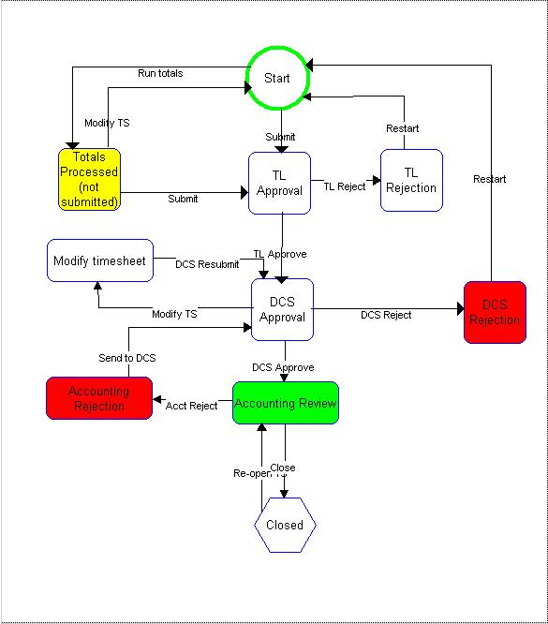

Expense Report Workflow

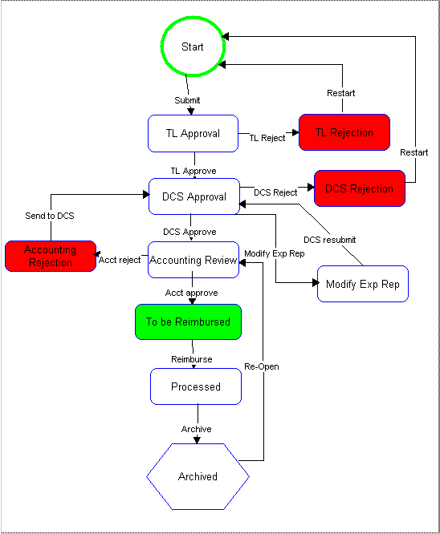

Travel Advance Workflow

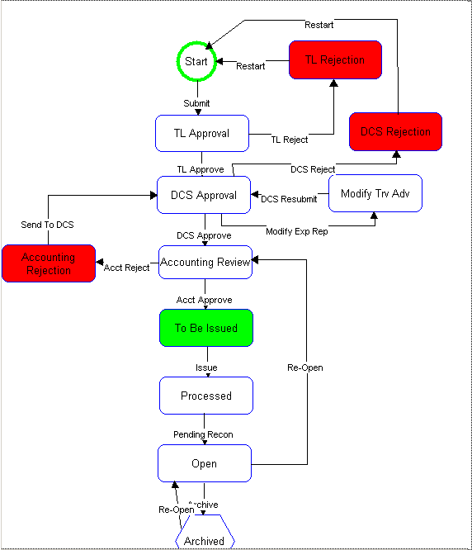

Appendix 6

Instructions for submitting Tenrox data via email
Templates for the three types of Email Forms (Timesheet, Expense, Travel Advance) will be sent to you via email. Double click on the appropriate file. This will automatically open Excel.

Save the file with your last name and the date (pay period start date for timesheets, start of the expense report or the start date of the trip for a travel advance).

EXAMPLE: outlaw_100304_timesheet.xls
outlaw_101004_expense.xls
outlaw_102704_travel.xls
Now you are ready to enter your information.

Timesheet
- Type your name and your 8-digit employee number
- Next enter the pay period dates (10/3 – 10/9)
- You should tell us how many files you are sending—if it is only one page then you would type page 1 of 1
- Double-click on the reason you are using the email option. If, for example, you are using it because you have a slow connect time at home, you would double-click on that and then left-click on the U in the tool bar. This will underline the reason. This is not a big deal—do not stress if you have trouble with this.
- Now you are ready to enter the date 10/3, 10/5 etc,
- Then enter the project—MDES or HRS for example
- Next you will type your worktype—main data collection admin for example.
- Then record the number of hours you worked that day under that worktype.
- Finally, if you are on overnight travel status or receiving a special differential you will tell us how many of the hours on that line qualify for the differential.
- If you have special information to convey, please use the notes field at the bottom of the timesheet.
- Once you have entered all your time (or all the time that will fit in the form), go to the toolbar at the top and left-click on the word file, then left-click on the words Send To, and finally left-click on Mail Recipient As Attachment.
- This will automatically put your file in an email.
- Left-click on the To: portion of the email. This will allow you to scroll down and select DCS Tenrox Processing Group (dcstenroxprocessinggroup@isr.umich.edu).
- In the subject line, please tell us you are submitting a timesheet and the dates of the pay week.
- Once you have selected your recipient and entered a subject left-click on Send. This will put the file in your outbox and it will be sent to Ann Arbor the next time you connect to ipass and do a send and receive in Outlook Express.

The deadline for emailing in timesheets is noon on Mondays.

Expense Report
- Type your name and your 8-digit employee number
- Next enter the dates for which you are submitting expenses—this is usually the same as the pay week. (10/3 – 10/9)
- You should tell us how many files you are sending—if it is only one page, then you would type page 1 of 1
- Double click on the reason you are using the email option. If, for example, you are using it because you have a slow connect time at home, you would double click on that and then left-click on the U in the tool bar. This will underline the reason. This is not a big deal—do not stress if you have trouble with this.
- Now you are ready to enter the date 10/3, 10/5 etc,
- Then enter the project—MDES or HRS for example
- Next you will type your worktype—main data collection admin, for example.
- Then record the expense category. Please use the categories listed in your Tenrox Manual.
- If the expense type was mileage, you will enter the number of miles driven and then in the memo field tell us where you drove (roundtrip home – Saginaw)
- For all other expenses you will enter a dollar amount and if necessary a note.
- If you have special information to convey, please use the Notes field at the bottom of the timesheet.
- Once you have entered all your time (or all the time that will fit in the form), go to the tool bar at the top and left-click on the word File, then left-click on the words Send To, and finally left-click on Mail Recipient As Attachment.
- This will automatically put your file in an email.
- Left-click on the To: portion of the email. This will allow you to scroll down and select DCS Tenrox Processing Group (dcstenroxprocessinggroup@isr.umich.edu).
- In the subject line, please tell us you are submitting an expense report and the dates of the submission.
- Once you have selected your recipient and entered a subject, left-click on Send. This will put the file in your outbox and it will be sent to Ann Arbor the next time you connect to ipass and do a send and receive in Outlook Express.

Travel Advance
- Type your name and your 8-digit employee number
- Next enter the dates for the trip (10/14 – 10/29)
- You should tell us how many files you are sending—if it is only one page then you would type page 1 of 1.
- Double click on the reason you are using the email option. If, for example, you are using it because you have a slow connect time at home, you would double click on that and then left-click on the U in the tool bar. This will underline the reason. This is not a big deal—do not stress if you have trouble with this.
- Now you are ready to enter the date 10/14, 10/15 etc,
- Then enter the project - MDES or HRS for example
- Next you will type your worktype – main data collection travel for example.
- Then record the expense category. Please use the categories listed in your Tenrox Manual.
- If the expense type was mileage, you will enter the number of miles driven and then in the memo field tell us where you drove (roundtrip home – Saginaw)
- For all other expenses you will enter a dollar amount and if necessary a note.
- If you have special information to convey, please use the Notes field at the bottom of the timesheet.
- Once you have entered all your time (or all the time that will fit in the form), go to the tool bar at the top and left-click on the word file, then left-click on the words Send To and finally left-click on Mail Recipient As Attachment
- This will automatically put your file in an email.
- Left-click on the To: portion of the email. This will allow you to scroll down and select DCS Travel Advance Group (traveladvance@isr.umich.edu).
- In the subject line, please tell us you are submitting a travel advance and the dates of the trip.
- Once you have selected your recipient and entered a subject, left-click on Send. This will put the file in your outbox and it will be sent to Ann Arbor the next time you connect to ipass and do a send and receive in Outlook Express.

Email Timesheet
Name: |  |  | 8 digit iwer #:
Date(s): |  |  | Page _________ of ________
Circle reason for faxing:
No computer Computer problems Slow connect time at home Traveler with slow connect time
Not trained to use online system Other (Specify):
Date | Project | Work Type |  | Hours Worked | Overnight or Special Differential
Please email this file to the DCS Tenrox Processing Group
By submitting this timesheet you are certifying that: the hours charged were incurred on the activities represented by the stated short code; the date indicated; in accordance to the Standard Practice Guide of the University of Michigan.
Notes:

Email Timesheet
Name: Mary Jane Miller |  |  |  |  |  |  | 8 digit iwer #: 11111234
Date(s): Aug. 7, 2005 |  |  |  |  |  |  | Page ___1______ of __1______
Circle reason for faxing:
No computer Computer problems Slow connect time at home Traveler with slow connect time
Not trained to use online system Other (Specify):
Date | Project |  | Work Type |  |  |  |  | Hours Worked |  |  | Overnight or Special Differential
8/7 | Dioxin |  | Main data collection travel |  |  |  |  | 5.00 |  |  | 0
Please email this file to the DCS Tenrox Processing Group
By submitting this timesheet you are certifying that: the hours charged were incurred on the activities represented by the stated short code; the date indicated; in accordance to the Standard Practice Guide of the University of Michigan.
Email Expense Submission Form
Name: |  |  |  |  |  | 8 digit iwer #:
Date(s): |  |  |  |  |  | Page _________ of ________
Underline reason for faxing:
No computer Computer problems Slow connect time at home Traveler with slow connect time
Not trained to use online system Other (Specify):
Date |  | Project |  | Work Type | Expense Category |  |  |  | Miles or Dollar Amount | Memo
Please email this file to the DCS Tenrox Processing Group
I certify that I have not received and will not receive reimbursement from another source(s) for any expense claimed. In the event that payment is received from another source(s) for any portion of the expenses claimed, I assume responsibility for repaying the University of Michigan in full for those expenses.
Notes:

Email Expense Submission Form
Name: Mary Jane Miller |  |  |  |  |  | 8 digit iwer #: 11111234
Date(s): January 3-January 7, 2004 |  |  |  |  |  | Page ___1______ of __1______
Underline reason for faxing:
No computer Computer problems Slow connect time at home Traveler with slow connect time
Not trained to use online system Other (Specify):
Date |  | Project |  | Work Type | Expense Category |  |  |  | Miles or Dollar Amount | Memo
01/03/2004 |  | HRS |  | Main Data Collection | R Payment |  |  |  | 0
01/05/2004 |  | HRS |  | Main Data Collection | Supplies
Please email this file to the DCS Tenrox Processing Group
I certify that I have not received and will not receive reimbursement from another source(s) for any expense claimed. In the event that payment is received from another source(s) for any portion of the expenses claimed, I assume responsibility for repaying the University of Michigan in full for those expenses.
Notes:

Email Travel Advance Request Form
Name: |  |  |  | 8 digit iwer #:
Travel Dates: |  |  |  | Page _________ of ________
Destination(s):
Underline reason for emailing:
No computer Computer problems Slow connect time at home Traveler with slow connect time
Not trained to use online system Other (Specify):
Date | Project | Work Type | Expense Category |  | Miles or Dollar Amount | Memo
Please email this file to the DCS Travel Advance Group
I certify that I have not received and will not receive reimbursement from another source(s) for any expense claimed. In the event that payment is received from another source(s) for any portion of the expenses claimed, I assume responsibility for repaying the University of Michigan in full for those expenses.
Notes:

Email Travel Advance Request Form
Name: Sally Smith |  |  | 8 digit iwer #: 11111234
Travel Dates: 06/05/2005 – 06/15/2005 |  |  | Page ____1_____ of ___1____
Destination(s): Denver, CO
Underline reason for emailing:
No computer Computer problems Slow connect time at home Traveler with slow connect time
Not trained to use online system Other (Specify):
Date | Project | Work Type |  | Expense Category | Miles or Dollar Amount | Memo
5/20 | MTF | Main Data Collection-Production |  | Respondent Payment | $100.00 | R Payments
5/20 | MTF | Main Data Collection-Production |  | Mileage | 100 | Mileage throughout segment
Please email this file to the DCS Travel Advance Group
I certify that I have not received and will not receive reimbursement from another source(s) for any expense claimed. In the event that payment is received from another source(s) for any portion of the expenses claimed, I assume responsibility for repaying the University of Michigan in full for those expenses.
Notes:

