Tenrox Team Leader Manual

Table of Contents

Assigning a Project to an Interviewer in Tenrox 1

Entering Tenrox and Your Timesheet View 1

Approving Timesheets in Tenrox 1

Multiple Projects—Approving From the Manager View 3

Rejecting a Timesheet 5

Multiple Projects—Rejecting From the Manager View 5

Checking Past Pay Periods 7

Administrator View 7

Timesheets Due and Zero Hours Timesheets 9

Entering Notes 9

Reviewing, Approving, and Rejecting Expense Reports in Tenrox 12

What You Need to Be Looking For 15

Approving Travel Advances in Tenrox 18

Out of office 19

Changing Your Role For a Time Entry 20

Note: This is a supplement for Team Leaders to the Tenrox Interviewer Manual. Most of the information about basic Tenrox operations are contained in the Interviewer manual. This supplement contains only Team Leader-specific information.

Assigning a Project to an Interviewer in Tenrox
Before users can enter time into Tenrox, the interviewer needs to be assigned the appropriate work types. Requests to add employees to projects must be sent to the DCS Tenrox Processing Group by a Project Manager.

SECTION 1: TIMESHEETS

Entering Tenrox and Your Timesheet View
Team Leaders have a variety of Views in Tenrox; Your personal Timesheet View, the Manager View, and the Administrator View. Tenrox will generally return you to the view you were in the last time you logged off. To access your personal timesheet, click on the “My Timesheet” link near the top of the Tenrox screen:

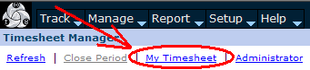
Fig. 1. The My Timesheet link.

You’ll then be taken to your timesheet view, and can enter your own time there.

Approving Timesheets in Tenrox
To approve timesheets, enter the Manger view (also called your “work list”). For example, to move from your personal Timesheet to your work list, left click on the “Timesheet Manager” link:

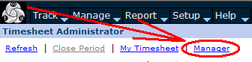
Fig. 2. The Manger link.

If you are already in the Manager view, you won’t see the link. That means you’re in the Manager view.

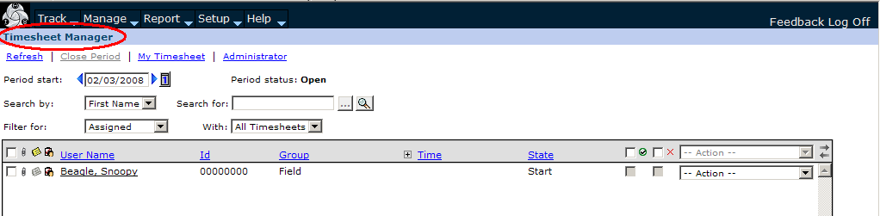
Fig. 3. The Timesheet Manager view.

After selecting Timesheet Manager, you can sort your work list by double clicking on any of the blue items on the grey header bar:

Fig. 4. The header bar.

If, for example, you left-click on State, it will sort your work list by the various approval states, in ascending alphabetical order:

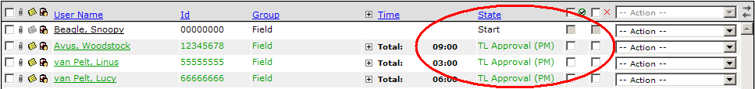
Fig. 5. Work list sorted by State.

If you click on State again, it will re-sort them in descending order.

Note that if you haven’t submitted it, your own timesheet also appears on your list. Timesheets ready for your review will be in the “TL Approval” state. Please note that only those who have submitted their timesheets will appear.

While you can approve or reject time from the summary view, you would only do so after having entered the timesheet and reviewed it in detail.

To enter an interviewer’s timesheet, left click on the interviewer’s name.

When reviewing timesheets:
- Verify that the interviewer has allocated time to the appropriately to the correct project(s) and work types.
- Verify that the hours claimed are in alignment with production levels.
- Review all overtime and differentials entries and make sure they were pre-approved.

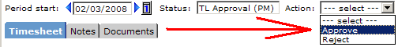
Fig. 6. The Approve action.

You’ll then see a pop-up window, asking you to confirm that you wish to continue:

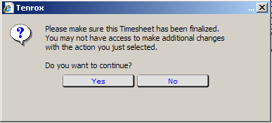
Fig. 7. The approval confirmation popup.

Click “yes” or “No” as appropriate.

If you feel that an interviewer is submitting inaccurate or fraudulent time or expense reports, contact your Production Manager immediately.

Multiple Projects—Approving From the Manager View
Please note that interviewers may have multiple projects on a timesheet. From the Timesheet Manager view, you will only be able to see the projects and worktypes for which you are the approver. You will not see time entries belonging to any other approver. You must go to Administrator view to see the full timesheet with all time entries displayed.

Timesheets will not appear in your Manager view until they have been submitted for TL Approval. Timesheets may, however, be viewed in Administrator view no matter their state. Never approve or reject timesheets from Administrator view. This should be done in Manager view only.
EXAMPLE:
Here is Snoopy Beagle’s timesheet, as he sees it: he has entered time for two projects, ABC Study 08, and Samplestudy 04.

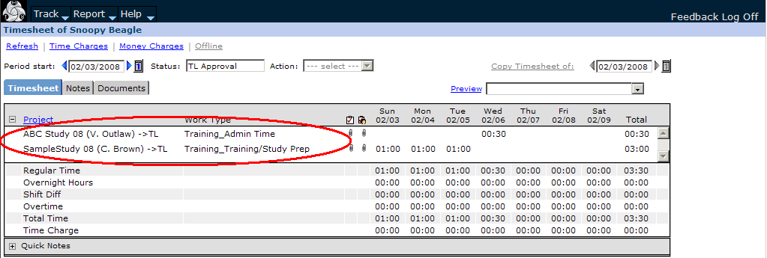
Fig. 8. Two projects entered on one timesheet.

In Manager view the approver for Snoopy’s project ABC 08 sees only the time entries for which they are the approver. Entries for the SampleStudy 04 project, which has a different approver, are not visible in Manager view. Note that even though the TL only sees time entries for ABC 08, the Totals column includes all of Snoopy’s hours:

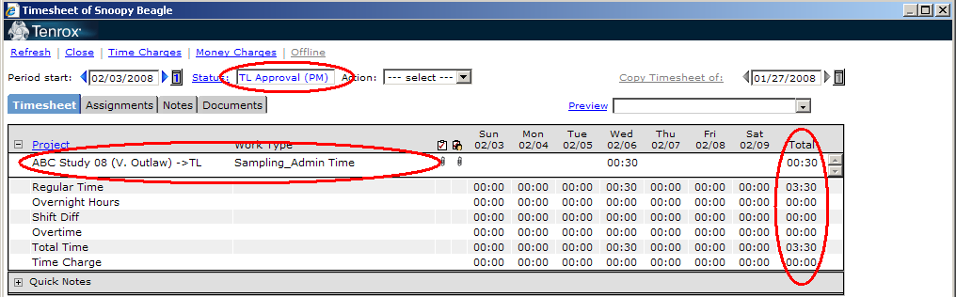
Fig. 9. Seeing only the ABC study from in TL Approval status.

Once the timesheet is approved, however, all other work types and time entries become visible:

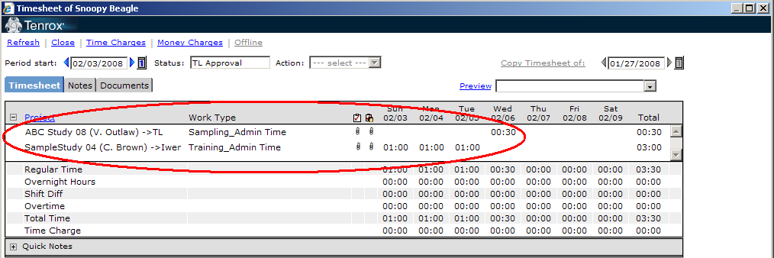
Fig. 10. Seeing only the ABC study from in TL Approval status.

Rejecting a Timesheet
To reject a timesheet, select “Reject” from the Action list. Tenrox will always then prompt you for a note, explaining the rejection. You are required to type in a note explaining the reason for the rejection. You must state a) what is wrong with the expense report, and b) what the employee must to do correct it.

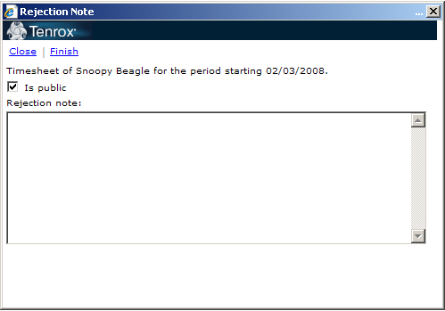
Fig. 11. The rejection note entry box.

Enter an explanation for the rejection into the space provided, and click “Finish”.

Although the Status may still read “TL Approval”, the lines for your work types will now appear in red. The timesheet will also no longer appear on your work list. When the interviewer views it again, they’ll see the status “TL Rejection”. Once the interviewer makes the change they will re-submit the timesheet to you for review.

Once you have approved the timesheet, it will likewise disappear off of your work list. You may need to click “Refresh” before it disappears.

If you approve a timesheet in error, please email the DCS Tenrox Processing Group immediately with the interviewer’s name and the timesheet date, and notify us of the error.

Multiple Projects—Rejecting From the Manager View

Please Note: When you reject a timesheet you must leave a detailed note explaining exactly what you have questions about or actions you want taken.

This information is critical during final audit, allowing DCS staff to get timesheets corrected and Interviewers paid on time.

Rejected projects and work types will appear in red on the Interviewer’s timesheet. A timesheet can have one project approved, but another rejected. In that case, the interviewer will see only the rejected project highlighted in red. He or she will have to revise and re-submit the rejected project hours. Once approved by all TLs, the timesheet will then move to DCS Approval status.

EXAMPLE: So, this:

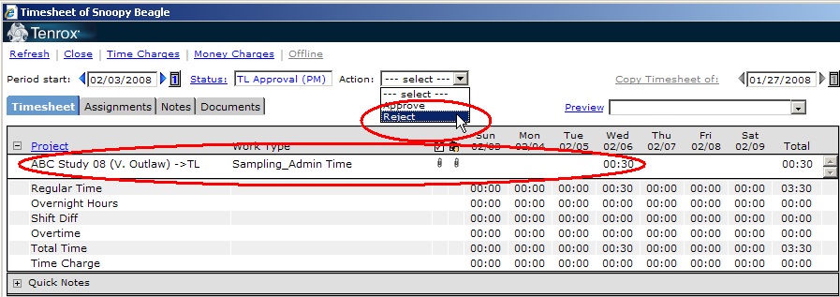
Fig. 12. Seeing only the ABC study just before rejection.

Changes to this, after selecting “Reject”:

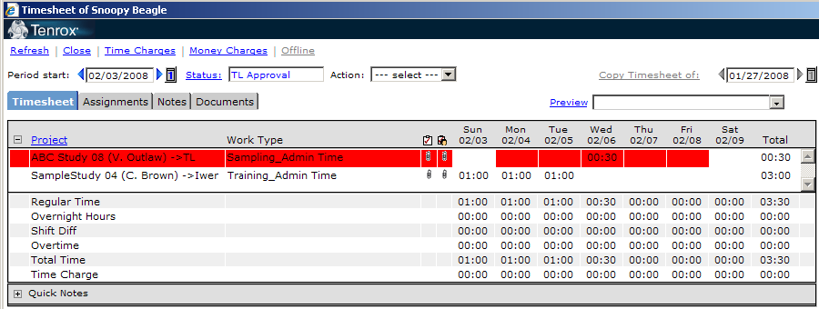
Fig. 13. Seeing the ABC study highlighted in red, and SampleStudy 04 unhighlighted, just after rejecting the ABC study.

The time I saw before I rejected the timesheet is now highlighted in red: this means the time has been rejected. I can now see the other time entered on the employee’s timesheet: it is not in red, which simply means it has either been approved or is awaiting review by the other TL. Although the status of the timesheet is still “TL Approval,” the employee will receive a rejection email, and if they view their timesheet again, they will likewise see the time for the rejected project highlighted in red. The employee can edit their timesheet and re-submit, by using the “Complete Project” option (see the Time and Expense Manual for details.)

Checking Past Pay Periods
Be sure to check past pay periods to see if there are late timesheets that need approval. You should check up to four weeks in the past. To view past pay period weeks, use the “Period start” calendar feature, as described in the Tenrox Interviewer Manual.

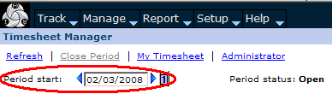
Fig. 14. The Period start feature.

Administrator View
There is another version of the Timesheet view besides the Timesheet Manager view, called the Administrator view. From the Timesheet Manager view, click “Administrator” to reach it:

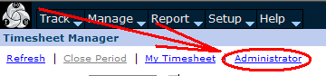
Fig. 15. The Administrator link.

If you don’t see this link, that means you’re already in the Administrator view.

The main Administrator view page is identical to the Manager view, except that it gives you a link back to the Manager view, and it displays lines for every employee in Tenrox.

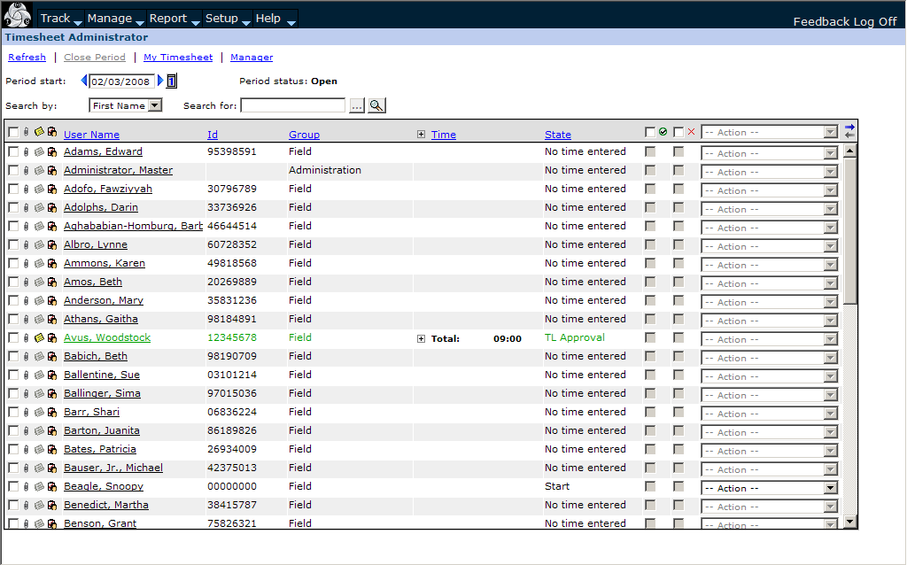
Fig. 16. The Administrator page.

From this view, you can search for any employee’s timesheet, by using the “Search by:” and “Search for:” functions:

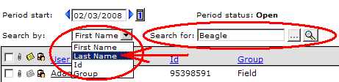
Fig. 17. Searching by Last Name.

Click on the drop-down “Search by:” menu to select a criteria type (Last Name, for example), and enter your criteria in the “Search for:” box, then click the magnifying glass icon to the right of the “Search for” box to execute your search. This is very similar to other types of searches in Tenrox.

Timesheets viewed in Administrator view will display all hours for all projects that an interviewer has entered, not just the hours for the project for which you are an approver.

You can, for example, use this view to search for timesheets from your team that have not yet been submitted, or for past timesheets that you have already approved, or if you ever need to view hours entered for a project for which you are not an approver.

You open timesheets from this view just as you would in the Manager view, by clicking on the name of the employee.

Some additional notes to consider for the Administrator view are:

- Some lines may appear in red on the list in the Administrator view. It simply flags the timesheet as unusual in some way—it may mean it contains overtime hours.

- A zero hours timesheet will be in “TL Approval” status, but will not have any time on it. Please see the section on zero hours timesheets below.

- Timesheets that you have already approved from the Manager view may still appear on the Administrator view in TL Approval, even though it has disappeared off your Manager work list. This means this timesheet has time for more than one TL on it, and is awaiting approval from another TL. Please see the section on multiple projects below.

Timesheets Due Dates and Zero Hours Timesheets
Interviewers are required to enter time daily and submit their timesheet weekly. Timesheets for your team are due by the close of business every Tuesday. You may work with your team members on a schedule that fits your team’s needs. If an iwer does not work any hours you may ask that they submit a zero hours timesheet but it is not required. Zero hours timesheets will not appear on your Manager list. You can only see zero hours timesheets from the Administrative view.

Entering Notes
To attach a note, go to the Notes tab:

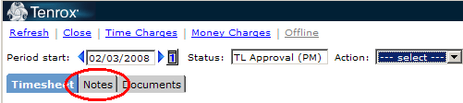
Fig. 18. The Notes tab.

This will open up the Notes window.

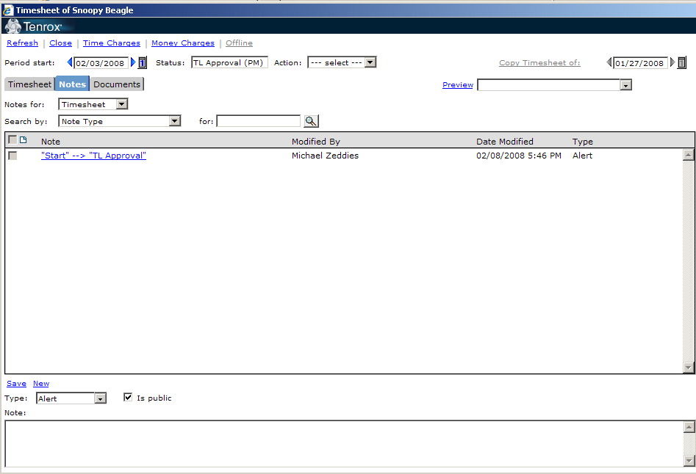
Fig. 19. The Notes window.

All changes from one status to another are recorded on the Notes screen. The above example shows that the timesheet was sent from Start status to TL Approval status by Michael Zeddies on 2/8/08 at 5:46pm.

Select the icon for a new note (the one that looks like a piece of paper with the corner folded down):

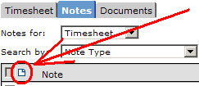
Fig. 20. The new note icon.

type your note in the box at the bottom left-hand corner of the screen (you can also just skip clicking the new note icon, and click directly on the box to type your note):

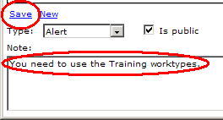
Fig. 21. Entering a note.

Then, left click on “Save”. Your note will appear on the list in the main window:

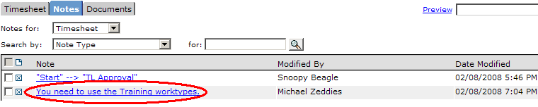
Fig. 22. A saved note.

To modify a note, click on the note itself—the underlined blue words--from the list. The note will then appear in the bottom area, and you can re-type it as needed, then click “Save”.

SECTION 2: EXPENSES

Reviewing, Approving, and Rejecting Expense Reports in Tenrox
Move to the “Expense” view as you normally would, by moving the cursor over the “Track” tab and selecting “Expense” from the drop-down menu. The first screen will always be a full list of all expense reports across all projects.

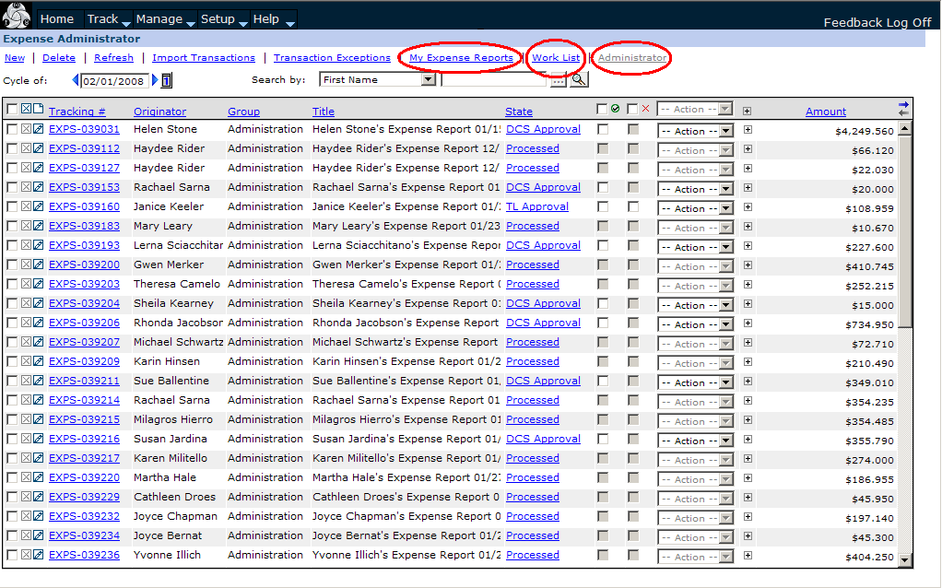
Fig. 23. The approver expense view.

To view only those expense reports for the employees on your team, click the blue “Work List” link at the top of the page. This will take you to your Work List:

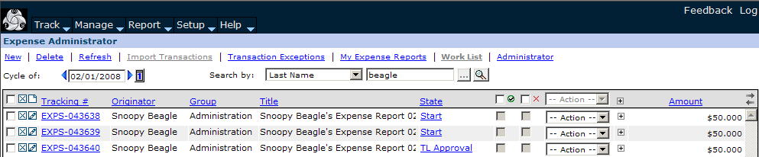
Fig. 24. The Work List view.

(Note that any of your expense reports currently in the “Start” state will also appear on this list.)

You can sort this list by left-clicking on any of the blue links on the tops of the columns, on the grey header bar. For example, if you left-click on State, it will sort your work list by the various approval states in ascending alphabetical order (and, if you left-click on it again, it will re-sort them in descending alphabetical order, just as with timesheets.)

Don’t forget you can also search for individual expense reports using the Tracking number, as explained in the Interviewer manual (under the section “Other Expense Report Features”.)

Note that the display is only for the current month. Be sure to check past cycles regularly for reports that may be submitted from past periods, by using the calendar buttons to change the date, just as you would in the Timesheet view:

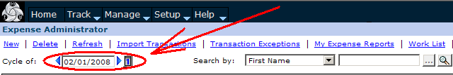
Fig. 25. The Cycle start date box.

Please note the list will contain both expense reports and travel advance requests. Use the tracking number to help you differentiate between the two. The tracking number for expense reports begin with EXPS, while the tracking numbers for travel advance requests begin with TRAW.

Only review expense reports for your team members and your project. Interviewers working more than one project at a time have been instructed to submit separate expense reports for each project.

You can approve expense reports from this screen, like the Administrator view for timesheets:

Fig. 26. Approving an expense report directly from the Work List.

However, as with timesheets, you must view an expense report before you approve or reject it. To open an interviewer’s expense report, left click on the blue expense report tracking number.

This will open up their expense report:

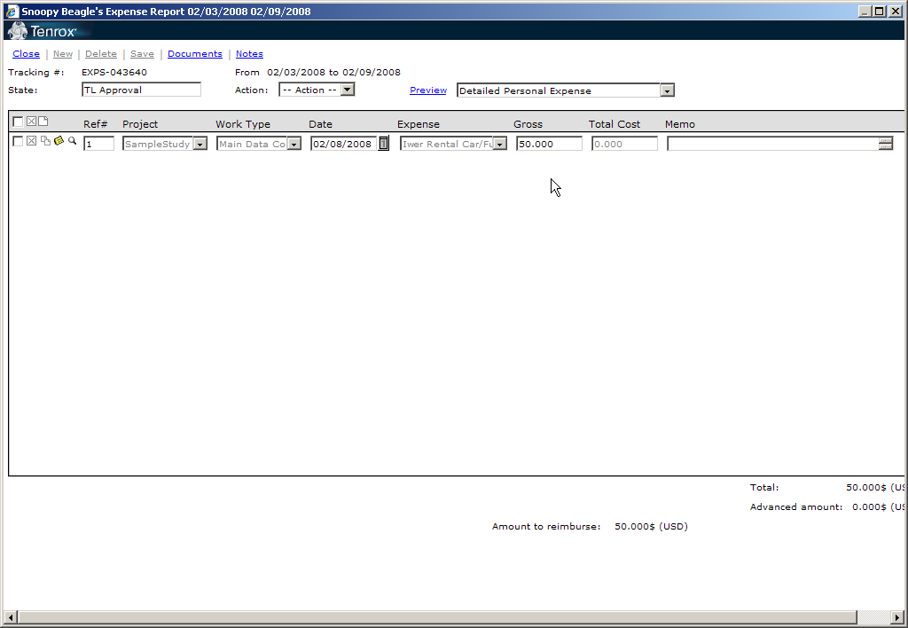
Fig. 27. An interviewer’s expense report.

Please make sure you check the project, work type, and expense type chosen by the interviewer for each expense. The work type should match the expense category chosen--for example, if the interviewer is claiming mileage, the work type should be for travel.

To approve an expense report select “TL Approve” from the action list:

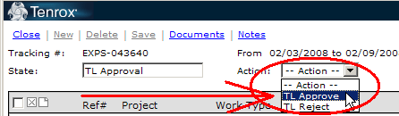
Fig. 28. Selecting TL Approve from the Action list.

To reject it, you would select “TL Reject” from the same list.

What You Need to Be Looking For
As a team leader, you should be checking that expenses claimed are in-line with production. Talk to your production manager about any anomalies immediately.

Review expense reports, checking for the following:

- Make sure the dates on the expense report match time submission.
- Make sure there is a match between the worktype and the expense category.
- Ask yourself: is the expense category correct?
- Does the amount make sense to you?
- Is the interviewer approved for that expense?
- Check the per diems for accuracy, comparing them with the Per Diem tables
- Review mileage entries for mileage memos.
- You should also be spot-checking to make sure that interviewers are not submitting expenses more than once. If you get overlapping expense report dates, please go back and check to see if this expense has been claimed on an earlier expense report.
- Expense reports should be made out for one week. Reject those made out for a month. (The iwer will have to start over and create a new expense report.) The only exception is for trips that span more than a week.

Once this has been done, you can approve the expense report.

If you approve an expense report in error, please contact the DCS Tenrox Processing Group immediately with the interviewer and the expense report tracking number, and notify us of the error.

You are not able to edit or correct interviewer expense reports. If you find an error, reject the expense report. To reject, select “TL Reject” from the Action drop-down list:

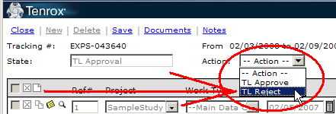
Fig. 29. Selecting TL Reject from the Action list.

You’ll get the certification pop-up—just click “Yes” to complete the rejection (or “No” to cancel it):

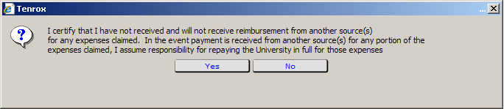
Fig. 30. The certification pop-up.

You will then be prompted to enter a note, just as with timesheets. You are required to type in a note explaining the reason for the rejection. You must state a) what is wrong with the expense report, and b) what the employee must to do correct it.

Here is an example of a note you might enter into the Rejection Note box for a rejected expense report:

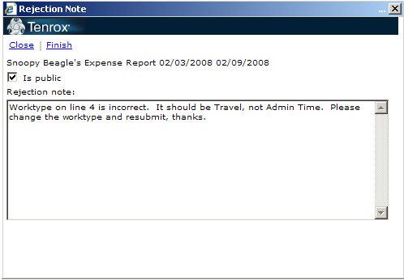
Fig. 31. Example of a rejection note.

You can also attach a note without rejecting the expense report (when reviewing or approving for example). To do this, left-click on the word notes on the top of the expense report,

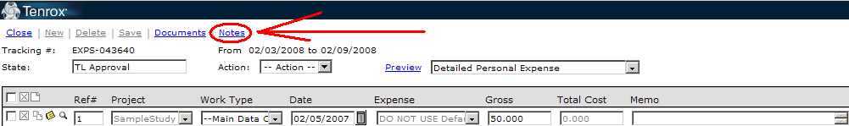
Fig. 32. The Notes link.

select the new note icon (again, it looks like a piece of paper with the corner folded down) from the Notes screen that pops up,

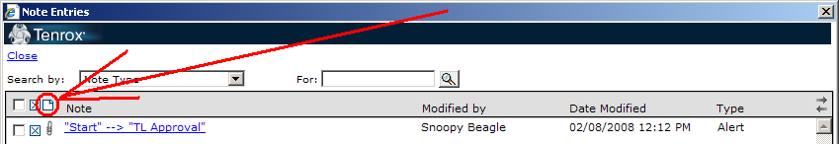
Fig. 33. Selecting TL Approve from the Action list.

type your note in the space at the bottom of the screen (you can also just skip clicking the new note icon, and instead click in the space at the bottom of the screen directly) and left-click on “Save”. Your note will then appear on the list, and you can click “Close” to exit the notes.

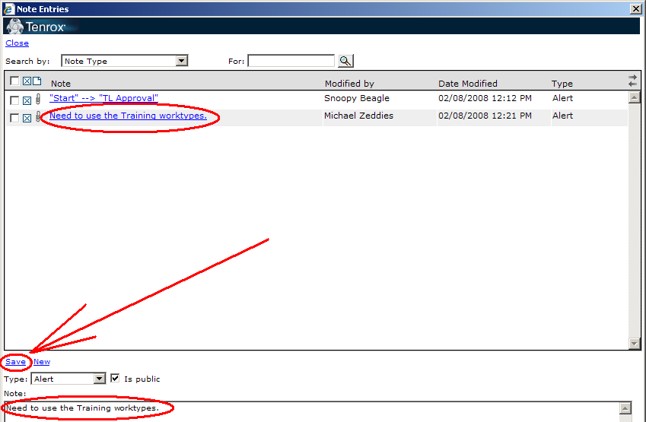
Fig. 34. Entering a note directly from the Note Entries screen.

After an expense report has been rejected, the status will change to “TL Rejection”:

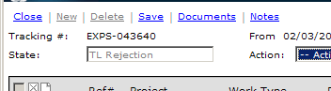
Fig. 35. The certification pop-up.

It will also now appear on the list on the main Expense Report tab view in “TL Rejection” status:

Fig. 36. An expense report in TL Rejection status on the expense report list.

Once the interviewer makes the changes, they will re-submit the expense report to you for review.

It is rare that an interviewer will not have any expenses. We expect that most interviewers will be submitting expenses at least once a week, but some interviewers may choose to submit them more often – this is fine. It is your responsibility to request expense reports from your team. Repeated late expense report submissions should be reported to the Production Manager.

Approving Travel Advances in Tenrox
To enter an interviewer’s travel advance request, left click on the tracking number, just as you would with an expense report:

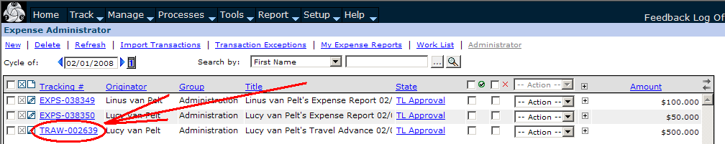
Fig. 37. Selecting a travel advance from the expense report list.

Please make sure you check the project, work types, and expense types chosen by the interviewer, just as you would on an expense report. The work type should match the expense category chosen. If, for example, the interviewer is claiming mileage, the work type should be one for travel. To approve an expense report select TL approve from the action list.

Only review travel advances for your team members and your project. Interviewers working more than one project at a time have been instructed to submit separate travel advance request for each project.

You are not able to edit or correct interviewer travel advance requests. If you find a major error, write a note and reject the travel advance request. The Interviewer should make the requested corrections then resubmit. If the error is minor, write a note for DCS staff, then resubmit the travel advance request.

Out of Office
If you are not going to able to approve your team’s timesheets, expense reports, or travel advances, you must inform your supervisor in advance and turn on the Out of Office feature in Tenrox. Move the cursor over the Track tab, then left-click on the “Out of Office” check-box to enable this feature:

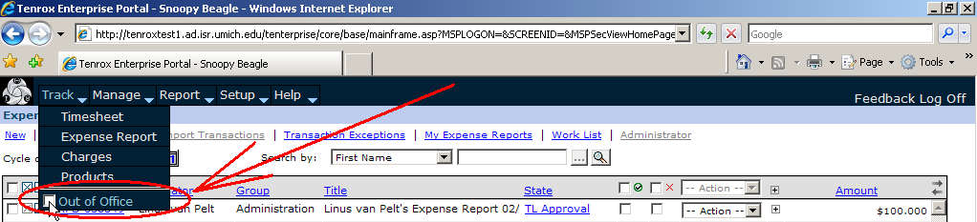
Fig. 38. Checking the Out of Office box.

All of your team’s timesheets will then automatically be routed to your alternate approver.

The next time you enter Tenrox, you will asked if you want to turn off your out of office:

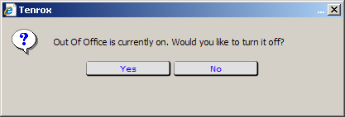
Fig. 39. The Out of Office notification popup.

Click “Yes” or “No” as appropriate. If you click “Yes”, Tenrox will automatically turn it off for you.

To turn it off manually, go back to the Out of Office check-box, by moving the cursor over the “Track” tab, and uncheck the Out of Office check-box.

Please note that “Out of Office” must be turned on prior to the submission of a timesheet in order for it to be redirected—it will not redirect them after they have been submitted.

Changing Your Role For a Time Entry
This section is addressed to Team Leaders who serve other roles on other projects, and concerns their own time entries on their own timesheets.

Some employees have different roles on different projects—Interviewer on one project, Team Leader on another. When entering time for these different projects, the time must be coded correctly according to the role the employee is assigned for that project.

Each employee has a default role for all time they enter in Tenrox. This is the role that a time entry is code with unless it is changed. The Role code is displayed in the Time Entry Details window—the same one as the Overnight Differential hours are displayed on.

The default role is always the highest role you are currently assigned (in ascending order: Study Aide, Interviewer, Field Coordinator, Team Leader, Production Coordinator).

To view the Role for a time entry, right-click on a time entry, and then click on Details.

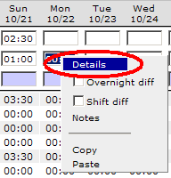
Fig. 40. Selecting the Details window.

You’ll see the Time Entry Details window pop up. On the Role line, your default role will be entered as text in the Role field. This is the Role assigned to that time entry.

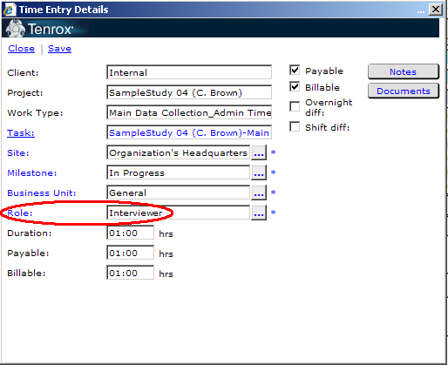
Fig. 41. The Role for a time entry.

If you work on a project under a different role than your default role in Tenrox, you must manually change the role for each time entry for that project.

So, if you are a Team Leader, but work as an Interviewer on another project, you must change the Role for each time entry you make for the project for which you work as an interviewer.

You will only change your role if specifically instructed to by a supervisor.

To change the Role for a time entry, enter the details screen as above, and click on the button beside the Role field—it will have a little ellipses inside it (…)

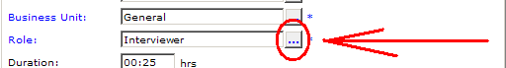
Fig. 42. Selecting the button to change a Role.

A list of roles will then pop up, called the Title List.

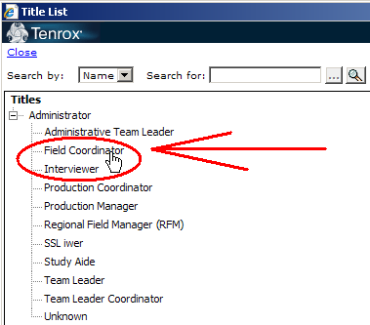
Fig. 43. Choosing a Role from the list.

Click on the role you need to change the Role of the time entry to. In this example, we are changing the Role of the time entry to Field Coordinator. Once you click on the new role, you’ll be taken back to the Details screen, where you’ll see the new role entered into the Role field.

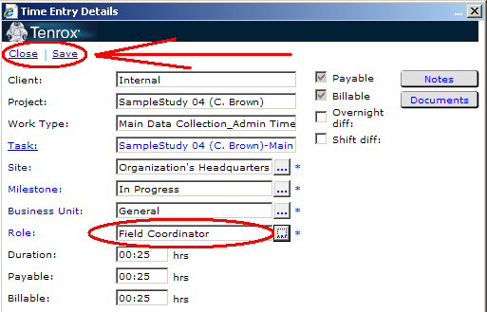
Fig. 44. Saving the new Role.
Remember to click “Save” to save your changes, then close the Details window. If you don’t click “Save”, you’ll get a popup message when you click Close:

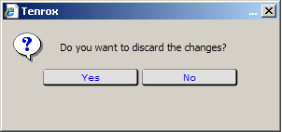
Fig. 45. The confirmation popup for changing a Role.

If you click “Yes”, you’ll return to your timesheet and no changes will be made to the entry. To save the new Role, click “No”, then click “Save” and then “Close” from the Details window.

