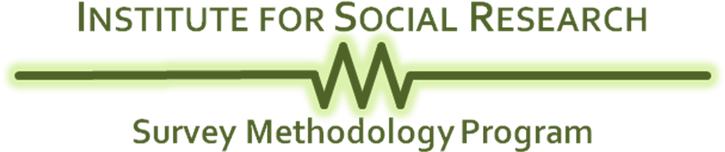

[Date]

Dear [Respondent First and Last Name]:

We are writing to invite your participation in a national survey about what you do in your leisure time—the time you aren’t at your job or taking care of your home or family—and how this is related to your health and well-being. This survey is being conducted by the Survey Methodology Program, Institute for Social Research. A questionnaire and a postage-paid return envelope are enclosed with this letter, along with $2 as a token of our appreciation. Filling out the questionnaire should take no more than about 15 minutes.

The information we request is vitally important. The responses to the survey will help to inform policy on these important topics.

The information you provide is confidential. However, based on experience we think there is a one in ten chance that someone will connect the names of respondents (that is, people who return their questionnaire) with their answers.

The people who receive this questionnaire have been selected at random from a listing of all U.S. households. In order for the results to be of scientific value, it is very important that everyone selected for the study respond. Because you cannot be replaced with anyone else, we hope that we can count on you.

Your participation is voluntary, and you may skip any question you do not wish to answer. If you have questions about the study, please call us toll-free at 1-877-292-0003 or e-mail us at SMPsurvey@isr.umich.edu. Should you have questions regarding your rights as a participant in research, please contact the Institutional Review Board – Behavioral Sciences, 540 East Liberty Street, Suite 202, Ann Arbor, MI 48104-2210; Phone: 734-936-0933; e-mail: irbhsbs@umich.edu.

Sincerely,

Eleanor Singer, Ph.D.
Institute for Social Research

