Disclosure Mail Survey
Web Logging Instructions –

For Logging - Returned Questionnaires, Undeliverables, and Phone Calls from R’s

- OUR LOGGING PROCEDURE –

- Questionnaire Returns (for ALL incoming qnrs.)

- Determine whether you have a returned (completed/partially completed) questionnaire, a completely blank questionnaire, a questionnaire with “REFUSED” written on it, or an undeliverable (questionnaire or postal notification).
    - If you have any kind of returned (from respondent) questionnaire, continue with the instructions below, Step a.
    - If you have an undeliverable, skip to Page 7, Undeliverables Logging.
    - If you have a large, cardstock postcard from the Post Office with a new address on it (returned by the Address Correction Service), skip to Page 8, Address Correction Service Logging.

- Enter the record for the SID that you have in hand. If the SID has been torn off the front page, please check the bottom left corner of page 7, on the inside of the questionnaire. There, unless the R has seen and removed that one, too, you will also find the SID for that questionnaire.
- Navigate to the Contact Attempts tab (Figure 9, below) for that record.
- Check your Contact “Type” (in this case, “Qnr. Mailing 1”), against the first digit in the SID at the upper left of the questionnaire. You will be able to tell which Contact Attempt to log by matching these first digits (please see list of Contact Attempt Types, below, in Figure 10).
- Enter the Contact Attempt by clicking on the number (“1”) in the Edit column that corresponds to the item that you are logging.
- Update your received date to the date when the questionnaire arrived in the office, and your disposition to the code corresponding to the questionnaire’s disposition (initially all with data will be 1051 = tentative).

Figure 9 – Contact Attempts tab
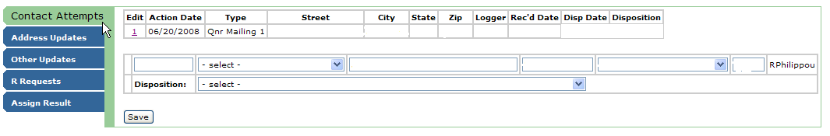
- The entry fields below the blank row are to be used for entering a new, outgoing contact attempt. You will rarely use these. Incoming mail will be logged against existing contact attempts in most cases, and will be accessed through the “Edit” column.

Figure 10 – List of Contact Attempt Types

Codes Corresponding to the Contact Attempt “Type” in the 3rd column (1-digit code
that precedes the SID):

1 – Questionnaire Mailing 1
2 – Questionnaire Mailing 2
3 – Replacement Questionnaire Mailing 1
4 – Replacement Questionnaire Mailing 2
5 – Follow-Up Postcard
6 – Non-Response Postcard
7 – Replacement Non-Response Postcard
8 – Debriefing Letter
9 – Email
10 – Telephone Call

SAVING YOUR UPDATES: SAVE Button in Lower Left-Hand Corner of All Tab Screens

