ABOUT NCDMHR
The National Center for Disaster Mental Health Research (NCDMHR) was formed to study and promote wellness in the face of disasters. It was funded in 2007 by the US Department of Health and Human Services, National Institutes of Health.
The NCDMHR is designed to look at new ways of studying disasters, to be able to rapidly respond to disasters, and to help community service agencies, scientists and policy makers improve coping for community residents after disasters. We would like to learn more about what consumers need and how they make decisions about getting care after disasters.
The NCDMHR brings together a group of researchers from a number of institutions who are experts in creating and conducting surveys, postdisaster services, prevention, working with children, and studying genes and hormones to see if there is a relationship to stress.
NCDMHR EXECUTIVE COMMITTEE
Fran H. Norris, PhD, Director and Principal Investigator
Sandro Galea, MD, DrPH, Research Director and co- Principal Investigator
Matthew Friedman, MD, PhD, Policy Advisor
Robert Groves PhD, Section Head, Survey Methodology
Dean Kilpatrick, Ph.D. Section Head, Public Health Intervention
Betty Pfefferbaum, MD, JD, Section Head Child Research
Steven Southwick, MD Section Head, Neurobiology of Resilience

NCDMHR ACADEMIC PARTNERS
Dartmouth College Dartmouth Medical School National Center for PTSD Dartmouth Trauma Interventions Research Center
University of Michigan Center for Social Epidemiology and Population Health at the School of Public Health Institute for Social Research
Medical University of South Carolina National Crime Victims Research and Treatment Center
Yale University and NCPTSD Clinical Neuroscience Division
University of Oklahoma Health Sciences Center Terrorism and Disaster Center (TDC) TDC’s Child & Family Disaster Research Training & Education Program

FOR MORE INFORMATION ABOUT NCDMHR please visit our website at www.ncdmhr.org
FOR MORE INFORMATION ABOUT THE GALVESTON BAY RECOVERY STUDY please call 800-759-7947

FOR MORE INFORMATION ABOUT YOUR RIGHTS AS A RESEARCH PARTICIPANT please contact the University of Michigan Institutional Review Board at: (734) 936-09339 or irbhsbs@umich.edu IRB #: HUM00019324

THE
GALVESTON BAY RECOVERY
STUDY

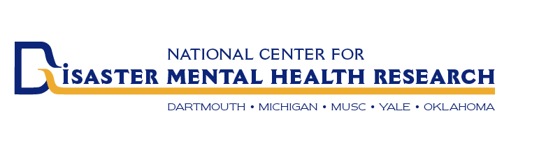

Funded by
Department of Health and Human Services National Institutes of Health

ABOUT THE EVENT NAME STUDY
We are conducting a research study about the experiences of people who were living in the community before and during EVENT NAME. Researchers from several institutions (see back of this brochure) are conducting this study. It is funded by the Department of Health and Human Services, National Institutes of Health. We are hoping that results from this study can help us understand reactions to EVENT NAME and how we can improve coping and services for those affected by EVENT NAME. We also want to be able to help those affected by future disasters. Households will be randomly selected for this study. The thoughts and opinions of community residents affected by EVENT NAME are very important to this study.

FREQUENTLY ASKED QUESTIONS
- What is this study all about?
- There are several parts to the study:
- There are 3 different telephone interviews over a period of 14 months The first interview lasts about 1 hour, the second and third about 35 minutes each
- After the first interview we will ask all participants for samples of their saliva and to complete a short questionnaire. Also, after the first interview, some people will be scientifically selected to participate
in an interactive computer educational program about stress
- After the second interview, some people will be scientifically selected to participate in an in-person program using a stress reduction workbook

FREQUENTLY ASKED QUESTIONS (cont.)
Q. Why do you want saliva?
A. We are looking for physical information about genes and hormones that might be related to stress.
Q. How much will it cost me to participate in this study?
A. There is no cost to you. As a thank you for your participation:
  - We pay $50 for the first of 3 telephone
interviews and $25 each for the 2nd and 3rd
briefer interviews.
  - We pay $10 for the saliva sample (including a brief survey)
  - We pay $10 for the educational website program
  - The stress reduction workbook programs\ is
free to participants

Q. Do I have to participate in this study?
A. No this study is completely voluntary. If you decide
to participate you can leave at any time or decline
to answer any questions. If you decide not to
participate there are no penalties and you will not
lose any benefits that you are entitled to.

Q. What are the benefits to me if I participate?
A. You may get direct benefits from some parts of the study like the educational website or the workbook sessions. Even if you don’t get a direct benefit from the study, your information may help others in the future if we can learn better ways to prevent and treat adverse reactions to disasters

Q. How did you choose my address/phone number?
A. Your address/number was selected at random by by
public lists like the census or random digit phone dialing for the area covered by the disaster.

HOW WE PROTECT YOUR PRIVACY
We have built a number of safeguards into the study to protect your personal information.
- Each participant will be given a unique identification number that will be kept completely separate from any identifying information like name, address or phone number. No one can link your personal information with your answers or other results from the research.
- All ID numbers and the links to identifying information are kept in a highly secured location at the University of Michigan’s Institute for Social Research. Only a few researchers from this study will have access to the information and only on a need-to-know basis.
- When we share the findings from the research it will only be done in summary form and no individual will be identifiable to the public.
- The researchers have obtained a Certificate of Confidentiality issued by the National Institutes of Health, which further protects your personal information. This certificate was designed especially to protect the confidentiality of research participants. It insures that we cannot be made to reveal any personally identifiable information about you.

